1

**SAS Viya 3.5 for Linux  
Auto Deployment Guide**

**目錄**

**1.** **準備安裝任務** 3

1.1 Linux Server服務規劃 3

1.2 事前準備檔案(control01) 3

1.3 特殊目錄結構(all) 4

1.4 事前準備檔案路徑(control01) 4

1.5 設定hostname(control01) 5

1.6 Linux加入AD網域(all) 6

1.7 給予一個AD account擁有root權限作為admin(all,需CCD協助) 8

1.8 建立root與admin的ssh金鑰配對(control01, control02) 8

1.9 配置Local Ansible Repository(control01, control02) 9

1.10 安裝Ansible(control01, control02) 10

1.11 定義ansible hosts(control01, control02) 11

1.12 配置inventory.ini(control01) 13

1.13 配置vars.yml(control01) 13

1.14 配置sitedefault.yml(control01) 16

1.15 配置Auto deployment所需的檔案(control01) 17

1.16 配置pre-install playbook(control01) 17

1.17 系統檢查(control01) 20

**2.** **開始自動化安裝** 23

2.1 任務清單 23

2.2 執行自動化安裝(control01) 23

**3.** **安裝後基本驗證** 24

3.1 驗證Admin帳號登入 24

3.2 驗證SAS Viya Service狀態 25

3.3 驗證SAS Viya版本 26

3.4 驗證 SAS License Product 27

3.5 驗證SAS 備份功能 27

3.6 驗證CAS相關設定 31

3.6.1 驗證CAS_ENABLE_CONSUL_RESOURCE_MANAGEMENT設定 31

3.6.2 驗證SERVICESBASEURL與MAXTABLEMEM 32

3.6.3 驗證sas workspace 位置 33

**4.** **安裝後進階設定驗證** 34

4.1 Post Configuration 34

4.2 設定SAS Environment Manager管理者sasboot 35

4.3 調整SAS Viya常用Service的Log Level 39

4.4 Enable dir creation for AD user 43

4.5 配置其他SAS Environment Manager管理者 45

4.5.1 配置Application Administrators 45

4.5.2 配置SAS Administrators 47

4.5.3 驗證administrators配置 48

4.6 測試連線Oracle DB 50

4.7 測試SAS StudioV功能 51

4.8 啟動SAS Viya可以使用X command 57

**5.** **Viya服務管理** 59

5.1 查詢Viya服務狀態 59

5.2 關閉Viya所有服務 62

5.3 開啟Viya所有服務 63

5.4 重啟Viya所有服務 64

**6.** **解除安裝** 65

**7.** **重新安裝步驟** 66

# **準備安裝任務**

## Linux Server服務規劃

|  |  |  |  |  |  |  |  |
| --- | --- | --- | --- | --- | --- | --- | --- |
| **Server Role** | **Host Name** | **IP Address** | **OS Version** | **CPU** | **RAM** | **SAS Cache Location** | **SAS binary Location** |
| load balance | balance | 10.70.12.20 | Redhat7.8 | 8 cores | 32 GiB | none | none |
| cas controller | control01 | 10.70.12.21 | Redhat7.8 | 80 cores | 64 GiB | /cache0/sascache01~80 | /opt/sas |
| backup cas controller | control02 | 10.70.12.22 | Redhat7.8 | 80 cores | 64 GiB | /cache0/sascache01~80 | /opt/sas |
| micro service | micro01 | 10.70.12.23 | Redhat7.8 | 80 cores | 128 GiB | /cache0/sascache01~80 | /opt/sas |
| micro service | micro02 | 10.70.12.24 | Redhat7.8 | 80 cores | 128 GiB | /cache0/sascache01~80 | /opt/sas |
| micro service | micro03 | 10.70.12.25 | Redhat7.8 | 80 cores | 128 GiB | /cache0/sascache01~80 | /opt/sas |
| PostgreSQL HA vip | pqsqlvip | 10.70.12.26 | On micro | On micro | On micro | On micro | On micro |
| cas worker | worker01 | 10.70.12.27 | Redhat7.8 | 80 cores | 256 GiB | /cache0/sascache01~80 | /opt/sas |
| cas worker | worker02 | 10.70.12.28 | Redhat7.8 | 80 cores | 256 GiB | /cache0/sascache01~80 | /opt/sas |
| cas worker | worker03 | 10.70.12.29 | Redhat7.8 | 80 cores | 256 GiB | /cache0/sascache01~80 | /opt/sas |

## 事前準備檔案(control01)

1. sas_repos

* -sas_repos_tsmc_2011.tar.part.xx

1. sas_viya_playbook_tsmc_2011.tgz
2. oracle-client

* oracle-instantclient19.3-basic-19.3.0.0.0-1.x86_64.rpm
* oracle-instantclient19.3-sqlplus-19.3.0.0.0-1.x86_64.rpm

1. rhel-7-server-ansible-2.8-rpms.tar
2. auto_deploy.yml, auto_deploy_vars.yml, auto_deploy_playbooks (需放置sas_viya_playbook資料夾內)

## 特殊目錄結構(all)

|  |  |
| --- | --- |
| 目錄 | 功用 |
| /CREPOS | Mount point of share storage(NAS) |
| /userap | Extra disk for /opt/sas link |

## 事前準備檔案路徑(control01)

解開事前準備檔案

|  |
| --- |
| [root@control01 ~]# cat sas_repos_tsmc_2011.tar.part.* > sas_repos_tsmc_2011.tar  [root@control01 ~]# tar xvf sas_repos_tsmc_2011.tar  [root@control01 ~]# tar zxvf sas_viya_playbook_tsmc_2011.tgz  [root@control01 ~]# tar zxvf rhel-7-server-ansible-2.8-rpms.tar |

將檔案放至對應位置

|  |  |
| --- | --- |
| 準備檔案 | 路徑位置 |
| Viya源檔案 | /CREPOS/sas_repos |
| Local Ansible Repository | /CREPOS/rhel-7-server-ansible-2.8-rpms |
| 安裝工具 | /CREPOS/viya_35c |
| 安裝所需腳本 | /CREPOS/viya_35c/sas_viya_playbook |
| Oracle client | /CREPOS/viya_35c/oracle_client |

## 設定hostname(control01)

設定主機名稱解析

|  |
| --- |
| [root@control01 ~]# vim /etc/hosts  10.70.12.20 balance.lzone.org balance  10.70.12.21 control01.lzone.org control01  10.70.12.22 control02.lzone.org control02  10.70.12.23 micro01.lzone.org micro01  10.70.12.24 micro02.lzone.org micro02  10.70.12.25 micro03.lzone.org micro03  10.70.12.27 worker01.lzone.org worker01  10.70.12.28 worker02.lzone.org worker02  10.70.12.29 worker03.lzone.org worker03 |

驗證主機名稱解析

|  |
| --- |
| [root@control01 ~]# hostname -f  [root@control01 ~]# hostname -i  [root@control01 ~]# hostname -s |

發送hosts

|  |
| --- |
| [root@control01 ~]# scp /etc/hosts *[all_nodes]*:/etc/ |

## Linux加入AD網域(all)

[all_nodes]

安裝Linux加入AD網域所需的相關套件

|  |
| --- |
| # yum install krb5-workstation krb5-libs realmd sssd samba-common adcli |

查詢所有網域

|  |
| --- |
| # realm list |

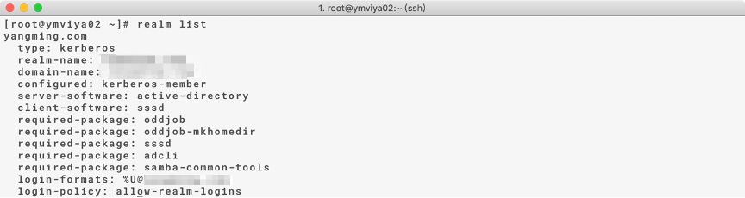

查詢特定網域

|  |
| --- |
| # realm discover *[ADserver_FQDN]* |

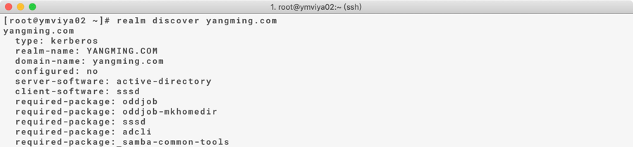

加入AD網域(all)

將Linux加入網域

|  |
| --- |
| #realm join *[ADserver_FQDN]* --user *[AD_acconunt]* |



驗證AD帳號加入

|  |
| --- |
| # id *[AD_user@domain]* |

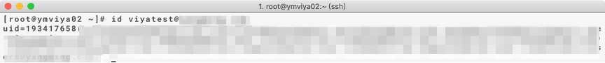

設定sssd(all)

|  |
| --- |
| # vim /etc/sssd/sssd.conf  use_fully_qualified_names = False  fallback_homedir = /home/%u |

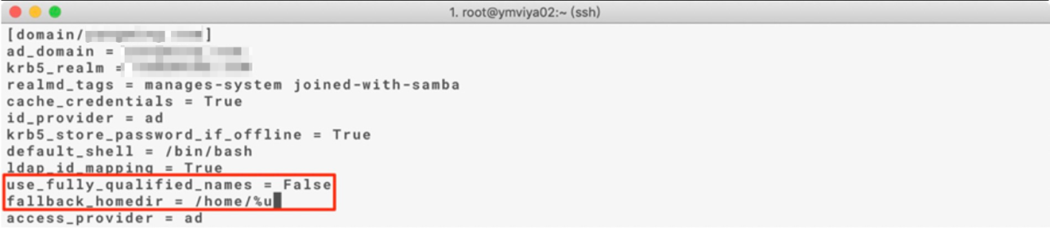

|  |
| --- |
| # systemctl restart sssd |

驗證AD帳號名

|  |
| --- |
| # id *[AD_user]* |



## 給予一個AD account擁有root權限作為admin(all,需CCD協助)

[all node]

|  |
| --- |
| # vi /etc/sudoers |

## 建立root與admin的ssh金鑰配對(control01, control02)

root的ssh金鑰配對

control01

|  |
| --- |
| [root@control01 ~]# ssh-keygen -q -t rsa -N '' -f ~/.ssh/id_rsa  [root@control01 ~]#  ssh-keyscan $(awk '{print $1}' /etc/hosts | grep '10.70.12') >> ~/.ssh/known_hosts  [root@control01 ~]# ssh-keyscan $(awk '{print $2}' /etc/hosts | grep '^[cmw]') >> ~/.ssh/known_hosts  [root@control01 ~]# ssh-keyscan $(awk '{print $3}' /etc/hosts | grep '^[cmw]') >> ~/.ssh/known_hosts  [root@control01 ~]# ssh-copy-id *[all_nodes]*  [root@control01 ~]# scp ~/.ssh/id_rsa* control02:~/.ssh/ |

control02

|  |
| --- |
| [root@control02 ~]#  ssh-keyscan $(awk '{print $1}' /etc/hosts | grep '10.70.12') >> ~/.ssh/known_hosts |

control01, control02驗證

|  |
| --- |
| # ssh *[all_nodes]* |

admin 的ssh金鑰配對

control01

|  |
| --- |
| [root@control01 ~]# su - p_viyaadmin  [p_viyaadmin @control01 ~]# ssh-keygen -q -t rsa -N '' -f ~/.ssh/id_rsa  [p_viyaadmin @control01 ~]#  ssh-keyscan $(awk '{print $1}' /etc/hosts | grep '10.70.12') >> ~/.ssh/known_hosts  [p_viyaadmin @control01 ~]# ssh-keyscan $(awk '{print $2}' /etc/hosts | grep '^[cmw]') >> ~/.ssh/known_hosts  [p_viyaadmin @control01 ~]# ssh-keyscan $(awk '{print $3}' /etc/hosts | grep '^[cmw]') >> ~/.ssh/known_hosts  [p_viyaadmin @control01 ~]# ssh-copy-id *[all_nodes]*  [p_viyaadmin @control01 ~]# scp ~/.ssh/id_rsa* control02:~/.ssh/ |

control02

|  |
| --- |
| [p_viyaadmin @control02 ~]#  ssh-keyscan $(awk '{print $1}' /etc/hosts | grep '10.70.12') >> ~/.ssh/known_hosts |

control01, control02驗證

|  |
| --- |
| # ssh *[all_nodes]* |

## 配置Local Ansible Repository(control01, control02)

配置repo設定檔

|  |
| --- |
| # vim /etc/yum.repos.d/ansible_local.repo  [ansible_local]  name=ansible local source  baseurl=file:///CREPOS/rhel-7-server-ansible-2.8-rpms  gpgcheck=0  enabled=1 |

驗證配置完成

|  |
| --- |
| # yum repolist |

Note : 檢查Red Hat Linux repo已掛上，若無可請CCD協助處理。

## 安裝Ansible(control01, control02)

|  |
| --- |
| # yum install ansible-2.8.6 |

驗證anisble安裝版本

|  |
| --- |
| # ansible --version |

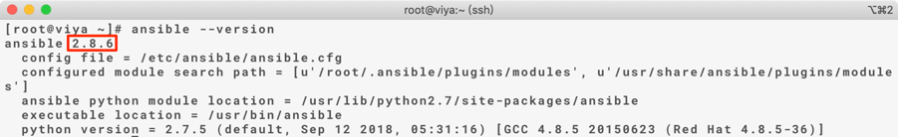

驗證anisble安裝完成

|  |
| --- |
| # ansible localhost -m ping |

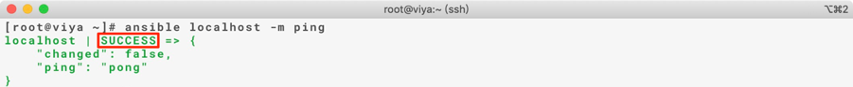

## 定義ansible hosts(control01, control02)

[node] 為不包含本機的所有server資訊，[cluster] 為包含本機的所有server資訊

[cas]為包含cas server及cas worker的所有server資訊，[controller]為包含primary及backup controller的所有server資訊，[worker] 為包含cas worker的所有server資訊，[microservice]為包含所有microervice的所有server資訊，[gpu]為包含cas worker的所有server資訊。

control01

|  |
| --- |
| [root@control01 ~]# vim /etc/ansible/hosts  [node]  10.70.12.[22:25]  10.70.12.[27:29]  [cluster]  10.70.12.[21:25]  10.70.12.[27:29]  [cas]  …  [controller]  …  [worker]  …  [microserivce]  …  [gpu]  … |

control02

|  |
| --- |
| [root@control01 ~]# vim /etc/ansible/hosts  [node]  10.70.12.21  10.70.12.[23:25]  10.70.12.[27:29]  [cluster]  10.70.12.[21:25]  10.70.12.[27:29]  [cas]  …  [controller]  …  [worker]  …  [microserivce]  …  [gpu]  … |

驗證control01, control02

|  |
| --- |
| # ansible cluster -m shell -a 'hostname -f'  # ansible node -m shell -a 'hostname -s' |

## 配置inventory.ini(control01)

進入sas_viya_playbook目錄

|  |
| --- |
| [root@control01 ~]# cd /CREPOS/viya_35c/sas_viya_playbook |

設置inventory.ini

|  |
| --- |
| [root@control01 sas_viya_playbook]# vim inventory.ini  deployTarget01 ansible_host=micro01.lzone.org  deployTarget02 ansible_host=micro02.lzone.org  deployTarget03 ansible_host=micro03.lzone.org  cas-controller01 ansible_host=control01.lzone.org  cas-controller02 ansible_host=control02.lzone.org  cas-worker01 ansible_host=worker01.lzone.org  cas-worker02 ansible_host=worker02.lzone.org  cas-worker03 ansible_host=worker03.lzone.org |

## 配置vars.yml(control01)

進入sas_viya_playbook目錄

|  |
| --- |
| [root@control01 ~]# cd /CREPOS/viya_35c/sas_viya_playbook |

設定vars.yml配置

|  |
| --- |
| [root@control01 sas_viya_playbook]# vim vars.yml  #調整license file(optional)  LICENSE_FILENAME: "SASViyaV0300_9CJXJF_Linux_x86-64.txt"  LICENSE_COMPOSITE_FILENAME: "SASViyaV0300_9CJXJF_70278032_Linux_x86-64.jwt"  #設定repo位置  REPOSITORY_WAREHOUSE: "file:///CREPOS/sas_repos/"  #設定vip  - HA_PGPOOL_VIRTUAL_IP: '*[postgresql_ha_vip]*'  # 設定cas_settings  CAS_SETTINGS:  1: ORACLE_HOME=/usr/lib/oracle/19.3/client64  2: JAVA_HOME=/usr/lib/jvm/jre-1.8.0  3: LD_LIBRARY_PATH=$LD_LIBRARY_PATH:$ORACLE_HOME/lib:$JAVA_HOME/lib/amd64/server    #設定cas config  CAS_DISK_CACHE: /cache0/sascache01:/cache0/sascache02:/cache0/sascache03:/cache0/sascache04:/cache0/sascache05:/cache0/sascache06:/cache0/sascache07:/cache0/sascache08:/cache0/sascache09:/cache0/sascache10:/cache0/sascache11:/cache0/sascache12:/cache0/sascache13:/cache0/sascache14:/cache0/sascache15:/cache0/sascache16:/cache0/sascache17:/cache0/sascache18:/cache0/sascache19:/cache0/sascache20:/cache0/sascache21:/cache0/sascache22:/cache0/sascache23:/cache0/sascache24:/cache0/sascache25:/cache0/sascache26:/cache0/sascache27:/cache0/sascache28:/cache0/sascache29:/cache0/sascache30:/cache0/sascache31:/cache0/sascache32:/cache0/sascache33:/cache0/sascache34:/cache0/sascache35:/cache0/sascache36:/cache0/sascache37:/cache0/sascache38:/cache0/sascache39:/cache0/sascache40:/cache0/sascache41:/cache0/sascache42:/cache0/sascache43:/cache0/sascache44:/cache0/sascache45:/cache0/sascache46:/cache0/sascache47:/cache0/sascache48:/cache0/sascache49:/cache0/sascache50:/cache0/sascache51:/cache0/sascache52:/cache0/sascache53:/cache0/sascache54:/cache0/sascache55:/cache0/sascache56:/cache0/sascache57:/cache0/sascache58:/cache0/sascache59:/cache0/sascache60:/cache0/sascache61:/cache0/sascache62:/cache0/sascache63:/cache0/sascache64:/cache0/sascache65:/cache0/sascache66:/cache0/sascache67:/cache0/sascache68:/cache0/sascache69:/cache0/sascache70:/cache0/sascache71:/cache0/sascache72:/cache0/sascache73:/cache0/sascache74:/cache0/sascache75:/cache0/sascache76:/cache0/sascache77:/cache0/sascache78:/cache0/sascache79:/cache0/sascache80  CAS_VIRTUAL_HOST: '*[loadbalance_fqdn]*'  CAS_VIRTUAL_PROTO: ‘http’  CAS_VIRTUAL_PORT: 80  CAS_ENABLE_CONSUL_RESOURCE_MANAGEMENT: 'TRUE'  cfg:  #gcport: 0  #httpport: 8777  port: *[cas_port]*  #colocation: 'none'  SERVICESBASEURL: 'http://*[loadbalance_fqdn]*'  MAXTABLEMEM: '536870912'  # Creates a workspaceserver sasenv_deployment file  FOUNDATION_CONFIGURATION:  #1: '# Comment about KEY'  #2: KEY=value  1: ORACLE_HOME=/usr/lib/oracle/19.3/client64  2: TWO_TASK=ORACLE_SID  3: ORAENV_ASK=NO  4: SASORA=V9  5: PATH=$PATH:$ORACLE_HOME/bin  6: LD_LIBRARY_PATH=$LD_LIBRARY_PATH:$ORACLE_HOME/lib:$JAVA_HOME/lib/amd64/server  7: COMPUTESERVER_TMP_PATH=/cache0/saswork  # Creates a workspaceserver sasv9_deployment.cfg file  SASV9_CONFIGURATION:  #1: '/* Comment about OPTION */'  #2: 'OPTION value'  1: '/* this will send the SASWORK to the /saswork location */'  2: 'WORK /cache0/saswork' |

## 配置sitedefault.yml(control01)

進入sas_viya_playbook/roles/consul/files目錄

|  |
| --- |
| [root@control01 ~]# cd /CREPOS/viya_35c/sas_viya_playbook/roles/consul/files/ |

設定sitedefault.yml配置

需設定AD連線資訊、Admin accout、backup sharedVault位置、Log Level以及JVM heap size等

|  |
| --- |
| config:  application:  sas.identities.providers.ldap.connection:  host: 'ip-10-249-7-135.ec2.internal'  port: '389'  url: 'ldap://${sas.identities.providers.ldap.connection.host}:${sas.identities.providers.ldap.connection.port}'  anonymousBind: 'false'  userDN: 'uid=sasldap,ou=users,dc=va82demo,dc=com'  password: 'demopw'  sas.identities.providers.ldap.group:  accountId: 'name'  baseDN: 'ou=groups,dc=va82demo,dc=com'  createdDate: 'createTimestamp'  distinguishedName: 'none'  member: 'member'  modifiedDate: 'modifyTimestamp'  objectClass: 'groupOfNames'  objectFilter: '(objectClass=groupOfNames)'  searchFilter: 'dn={0}'  sas.identities.providers.ldap.user:  accountId: 'uid'  baseDN: 'ou=users,dc=va82demo,dc=com'  createdDate: 'createTimestamp'  distinguishedName: 'none'  memberOf: 'memberOf'  modifiedDate: 'modifyTimestamp'  objectClass: 'inetOrgPerson'  objectFilter: '(objectClass=inetOrgPerson)'  searchFilter: 'uid={0}'  sas.identities:  administrator: 'viyademo01'  sas.commons.web.security.cors:  allowCredentials: 'true'  allowedHeaders: '*'  allowedMethods: '*'  allowedOrigins: '*'  deploymentBackup:  sas.deploymentbackup:  sharedVault: /CREPOS/backup  jobTimeout: 600  retentionPeriod: 30  scheduledBackupAllowed: false  SASJobExecution:  logging.level:  com.sas.jobexec: DEBUG  compute:  logging.level:  com.sas.compute: DEBUG  jvm:  java_option_xmx: -Xmx4096m  jobExecution:  logging.level:  com.sas.jobExecution: DEBUG  jobFlowScheduling:  logging.level:  jobFlowScheduling: DEBUG  scheduler:  logging.level:  com.sas.scheduling: DEBUG  SASStudioV:  jvm:  java_option_xms: -Xms4096m  java_option_xmx: -Xmx4096m |

## 配置Auto deployment所需的檔案(control01)

確認auto_deploy.yml, vars.yml以及auto_deploy_playbooks以及資料夾已放置sas_viya_playbook資料夾中，並確認auto_deply_playbooks裡面有yml檔存放

|  |
| --- |
| [root@control01 ~]# ls -lr /CREPOS/viya35_c/sas_viya_playbook | grep auto_deploy  [root@control01 ~]# ls -lr /CREPOS/viya35_c/sas_viya_playbook/auto_deploy_playbooks  check_hostvars.yml  check_sitedefault.yml  clean_softlink.yml  clean_yum.yml  create_cache.yml  create_sharedmount.yml  create_softlink.yml  install_oracle.yml |

編輯auto_vars.yml填入對應變數值(以下黃底部分都需要修改)

|  |
| --- |
| [root@control01 ~]# vi /CREPOS/viya35_c/sas_viya_playbook/auto_vars.yml  ## Auto deploy  ORACLE_CLIENT_RPM_LOCATION: "/CREPOS/oracle"  SAS_VIYA_PLAYBOOK_LOCATION: "/CREPOS/viya35_c/sas_viya_playbook"  sas_gid: "1001"  sas_uid: "1001"  cas_uid: "1002"  ## Post Config  cgroup_p1: 40  cgroup_p2: 30  cgroup_p3: 20  cgroup_p4: 10  ## Login Information  adm_usr: "viyademo01"  adm_pwd: "demopw"  micro: "http://ip-10-249-7-37.ec2.internal" |

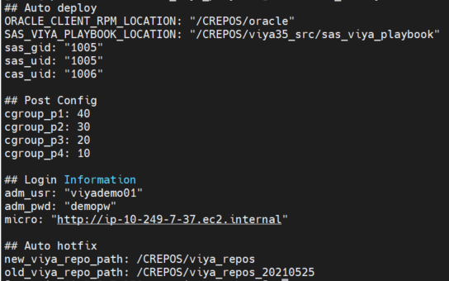

## 配置pre-install playbook(control01)

進入sas_viya_playbook目錄

|  |
| --- |
| [root@control01 ~]# cd /CREPOS/viya_35c/sas_viya_playbook |

確認pre-install playbook

NTP設定

|  |
| --- |
| # vi /CREPOS/viya_35c/sas_viya_playbook/viya-ark/playbooks/pre-install-playbook/roles/viya-ark.preinstall/defaults/main.yml  packages_nicetohave:   * ntp   # - chrony |

|  |
| --- |
| # vi /CREPOS/viya_35c/sas_viya_playbook/viya-ark/playbooks/pre-install-playbook/roles/viya-ark.preinstall/tasks/pre.ntp_config.yml  ---  ####################################################################  ## NTP Check  ####################################################################  # Test harness:  # make it pass  # ansible-playbook viya_pre_install_playbook.yml -i inventory --tags ntp_config -e use_pause=0  # make it fail  #  - block:  ## block start  - name: Check if ntp service exists  stat: path=/usr/lib/systemd/system/ntpd.service  register: ntpd_service  - name: Ensures NTP service is started and enabled  service:  name: "{{ item }}"  state: started  enabled: yes  when: ntpd_service.stat.exists  with_items:  - ntpd  # - name: Make sure ntp is running  # systemd:  # state: started  # name: chronyd  # - name: Make sure ntp is enabled  # systemd:  # name: chronyd  # enabled: yes  # masked: no  ## block end  tags:  - fixable  - ntp_config |

nproc, nofile設定

|  |
| --- |
| # dealing with ulimits:  default_ulimits_dir: /etc/security/limits.d  ulimit_file_loc: /etc/security/limits.d/viya_3.5_limits.conf  ulimits:  -  comment: "#Added (1) for Viya Installation"  domain: "*"  item: nofile  type: "-"  use_max: true  use_min: false  value: 300000  -  comment: "#Added (2) for Viya Installation"  domain: "{{sas_user}}"  item: stack  type: "-"  use_max: true  use_min: false  value: 10240  -  comment: "#Added (3) for Viya Installation"  domain: "*"  item: nproc  type: "-"  use_max: true  use_min: false  value: 200000  -  comment: "Added (4) for SAS Viya VI Installation"  domain: "{{sas_user}}"  item: nofile  type: "-"  use_max: true  use_min: false  value: 300000  -  comment: "Added (5) for SAS Viya VI Installation"  domain: "{{sas_user}}"  item: nproc  type: "-"  use_max: true  use_min: false  value: 200000 |

## 系統檢查(control01)

hostname

|  |
| --- |
| # ansible cluster -m shell -a 'hostname -f && hostnamectl status' |

OS version

|  |
| --- |
| # ansible cluster -m shell -a 'cat /etc/redhat-release' |

File System

|  |
| --- |
| # ansible cluster -m shell -a 'df -h /opt /userap /cache0 /CREPOS' |

fstab

|  |
| --- |
| # ansible cluster -m shell -a 'cat /etc/fstab' |

CPU

|  |
| --- |
| # ansible cluster -m shell -a 'lscpu | grep “CPU(s)”' |

RAM

|  |
| --- |
| # ansible cluster -m shell -a 'lsmem | grep Total' |

網卡

|  |
| --- |
| # ansible cluster -m shell -a 'ip addr show' |

NTP

確認 CHRONYD 服務為 stop 及 disabled

|  |
| --- |
| # ansible cluster -m shell -a 'systemctl status chronyd'  # ansible cluster -m shell -a 'systemctl disable chronyd' |

將 /etc/sysconfig/ntpd 中 OPTIONS=”-g -x” 更改為 OPTIONS=”-g” (更改原因ref: <https://access.redhat.com/solutions/3759171>)

|  |
| --- |
| # vi /etc/sysconfig/ntpd |

將設定檔複製到其他台 viya cluster，並重啟 ntpd 生效

|  |
| --- |
| # ansible CommandLine -i /CREPOS/viya_35c/sas_viya_playbook/inventory.ini  -m copy -a 'src=/etc/sysconfig/ntpd dest=/etc/sysconfig/ntpd'  # ansible CommandLine -i /CREPOS/viya_35c/sas_viya_playbook/inventory.ini  -m shell -a "systemctl restart ntpd" |

確認ntpd服務正常，等待 5-10分鐘後再往下進行

|  |
| --- |
| # ansible CommandLine -i /CREPOS/viya_35c/sas_viya_playbook/inventory.ini  -m shell -a "systemctl status ntpd" |

確認 ntpq 正常 (若是無標示 * 則等一段時間後再確認)

|  |
| --- |
| # ansible CommandLine -i /CREPOS/viya_35c/sas_viya_playbook/inventory.ini  -m shell -a "ntpq -pn" |

確認 ntp 狀態 (若非synchronised to NTP server 則等一段時間後再確認)

|  |
| --- |
| # ansible CommandLine -i /CREPOS/viya_35c/sas_viya_playbook/inventory.ini  -m shell -a "ntpstat" |

確認 ntp 狀態 (若非NTP synchronized: yes則等一段時間後再確認)

|  |
| --- |
| # ansible CommandLine -i /CREPOS/viya_35c/sas_viya_playbook/inventory.ini  -m shell -a "timedatectl" |

時區

|  |
| --- |
| # ansible cluster -m shell -a 'date' |

Java version

|  |
| --- |
| # ansible cluster -m shell -a 'rpm -qa | grep java' |

# **開始自動化安裝**

## 任務清單

自動化安裝任務清單如下

|  |
| --- |
| 1. 安裝oracle client 2. 建立cache folder 3. 配置host_vars 4. Pre-install 5. 配置soft link 6. 配置CAS share mount 7. 清空yum cache 8. 運行system-assessment做安裝前檢查 9. 運行site.yml進行安裝 10. Disable Viya Auto Start |

## 自動化安裝使用之Script

自動安裝相關Script放置於 /CREPOS/viya35_c/sas_viya_playbook/

|  |  |  |
| --- | --- | --- |
| Script名稱 | Script功能 | Script 路徑 |
| auto_deploy.yml | 打包所有子playbook | auto_deploy.yml |
| auto_vars.yml | 紀錄自動化變數 | auto_vars.yml |
| Install_oracle.yml | 安裝 orcale於所有machine | auto_deploy_playbooks/install_oracle.yml |
| create_cache.yml | 在所有machine建立/cache0/sascache01~/cache0/sascache、 /cache0/saswork、/CREPOS/tklog | auto_deploy_playbooks/create_cache.yml |
| clean_softlink.yml | 刪除掉舊的softlink，確認不會重複建立 | auto_deploy_playbooks/clean_softlink.yml |
| check_hostvars.yml | 在playbook下面建立host_var並且建立每個server之網卡檔案 | auto_deploy_playbooks/check_hostvars.yml |
| check_sitedefault.yml | 確認sitedefault存在正確路徑，並且根據內容建立SharedVault | auto_deploy_playbooks/check_sitedefault.yml |
| create_softlink.yml | 為 /opt/sas建立softlink至 /userap/sas | auto_deploy_playbooks/create_softlink.yml |
| create_sharedmount.yml | 在primary controller 以及 backup controller為 cas 建立 shared mount位置 /CREPOS/caslib_info | auto_deploy_playbooks/create_sharedmount.yml |
| clean_yum.yml | 清除 yum cache資訊以及vars 變數之cache | auto_deploy_playbooks/clean_yum.yml |

## 執行自動化安裝(control01)

需確認移動執行目錄至sas_viya_playbook底下，再開始進行自動化安裝

|  |
| --- |
| [root@control01 ~]# cd /CREPOS/viya35_c/sas_viya_playbook  [root@control01 ~]# time sudo ansible-playbook -i inventory.ini auto_deploy.yml --skip-tags skipstrogefail -e "@auto_vars.yml" |

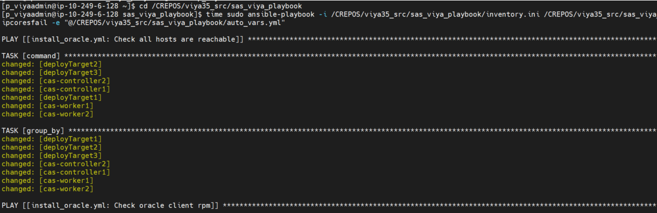

# **開始自動安裝後設定**

## 任務清單

自動化安裝後設定任務清單如下

|  |
| --- |
| 1. 設定Apache Timeout 為 3600 2. 設定 Cmdui 3. 設定 Dirty ratio 4. 設定 AD 登入自動創建 home 目錄 5. 設定 EG Disable SSL 6. 設定 tklog 7. 設定 sas-admin 的 End-point 8. 設定cgroup policy 9. 重啟特定服務讓 Config 生效 |

## 自動化安裝使用之Script

自動安裝相關Script放置於 /CREPOS/viya35_c/sas_viya_playbook/

|  |  |  |
| --- | --- | --- |
| Script名稱 | Script功能 | Script 路徑 |
| auto_postconfig.yml | 包含所有後設自動化 | auto_deploy.yml |
| auto_vars.yml | 紀錄自動化變數 | auto_vars.yml |

## 執行自動化安裝後設定 (control01)

|  |
| --- |
| [[root@control01 ~]# sudo ansible-playbook -i /CREPOS/viya35_c/sas_viya_playbook/inventory.ini /CREPOS/viya35_c/sas_viya_playbook/auto_postconfig.yml -e "@/CREPOS/viya35_src/sas_viya_playbook/auto_vars.yml" |

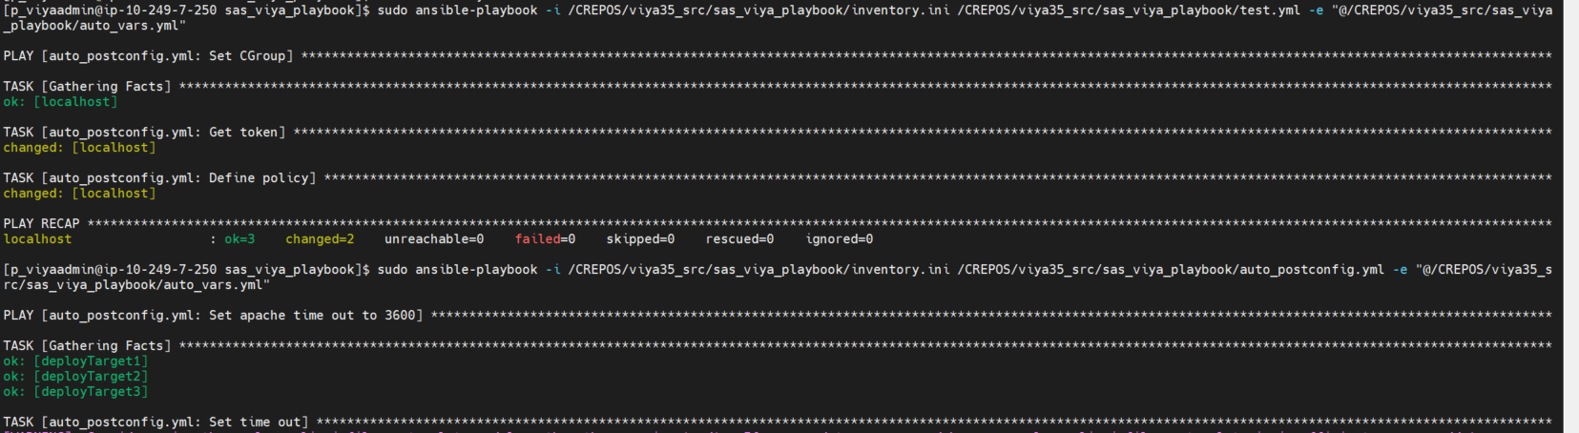

# 開始手動安裝後設定

## 4.1 設定SAS/CAS 帳號密碼時效管理內容(需填寫ITSR單)

|  |
| --- |
| #ansible cluster -m shell -a 'sudo chage -I -1 -m 0 -M 99999 -E -1 sas'  #ansible cluster -m shell -a 'sudo chage -I -1 -m 0 -M 99999 -E -1 cas' |

檢查密碼時效管理內容

|  |
| --- |
| #ansible cluster -m shell -a 'sudo chage -I sas'  #ansible cluster -m shell -a 'sudo chage -I cas' |

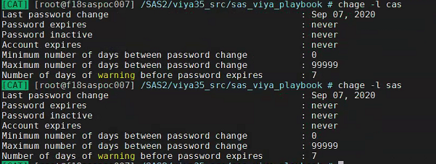

## 4.2 設定SAS Environment Manager管理者sasboot

sasboot為SASEnvironmentManager安裝好後暫時產生的管理者帳號,

登入任一台micro service node, grep重設sasboot密碼之url

|  |
| --- |
| [root@micro01 ~]# grep sasboot /var/log/sas/viya/saslogon/default/sas-saslogon_2019-12-06_01-26-42.log  # sas-saslogon_*[the lastest date]*.log |



[https://*[loadbalance_url]*/*[grep_url]*](https://[loadbalance_url]/%5bgrep_url%5d)

登入SASEnvironmentManager,

開啟瀏覽器, 建議使用firefox或chrome,

此處使用firefox為例, 輸入上方url,

點選”進階”=>點選”接受風險並繼續”

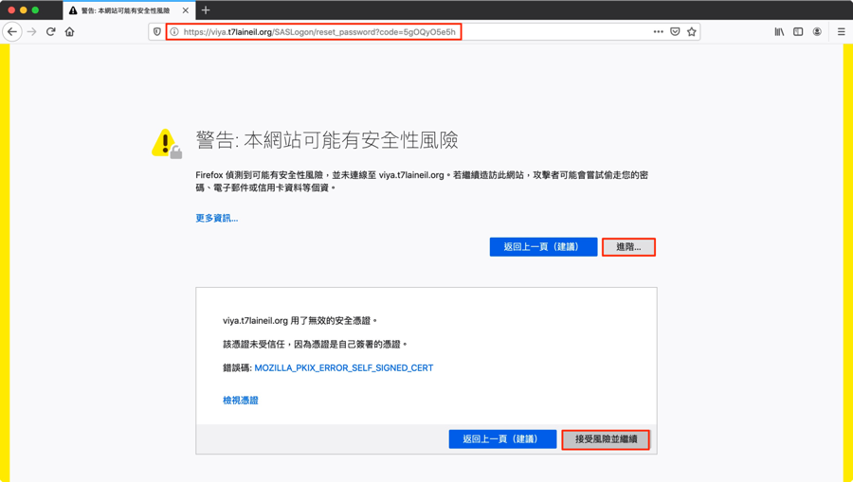

重設密碼, 此範例將密碼重設為”Orion123”

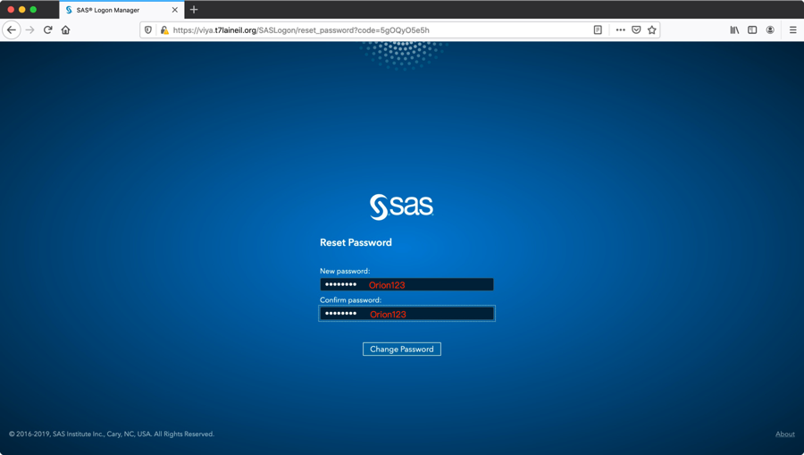

使用sasboot並搭配上面設定之密碼登入

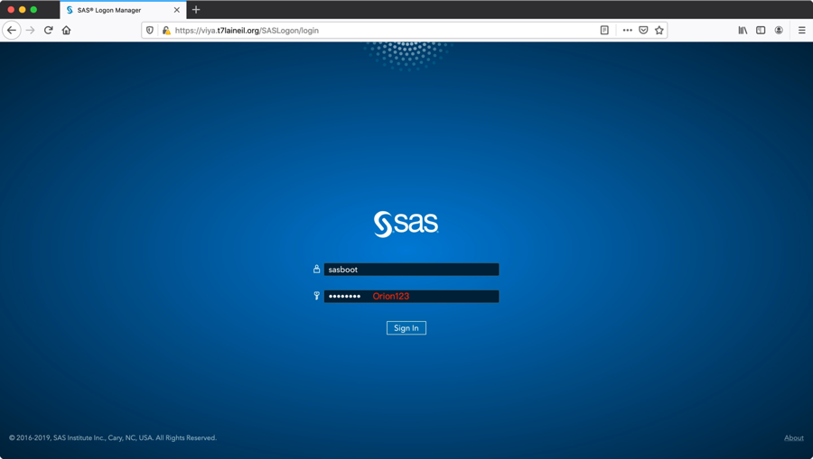

點選”是”, 加入可代入群組

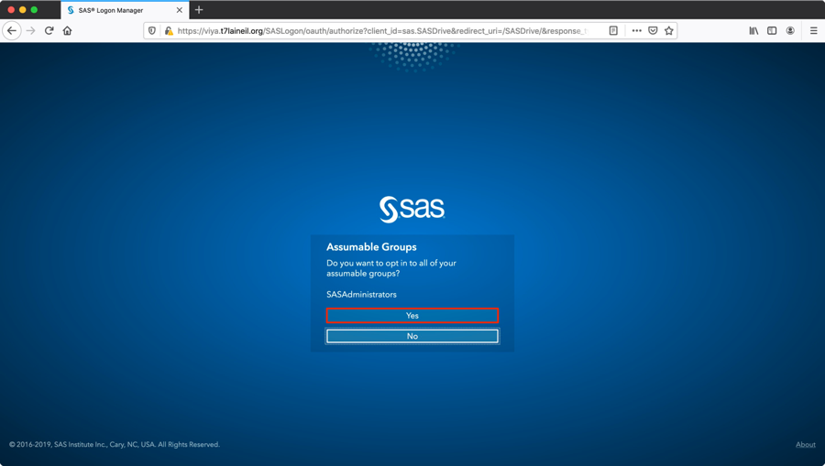

選擇主題設定或略過

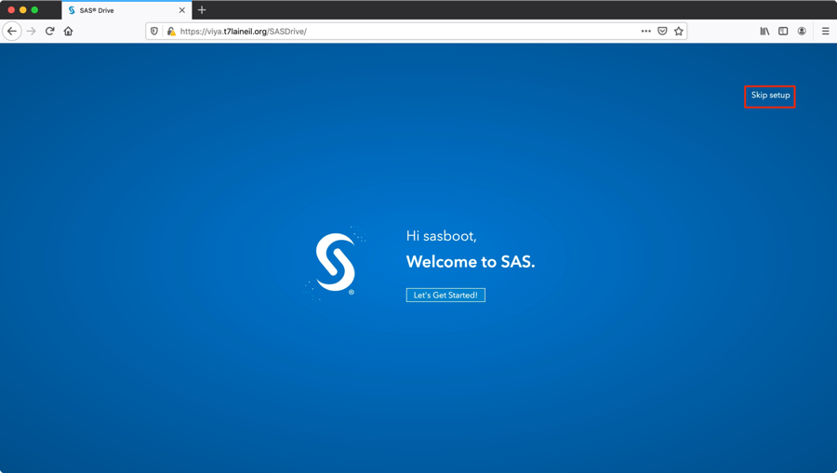

初次登入sasboot預設畫面

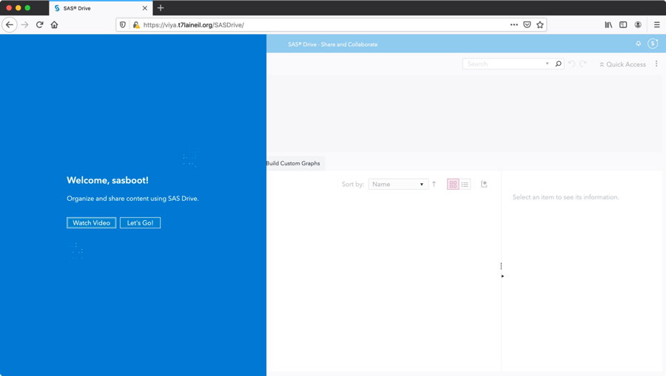

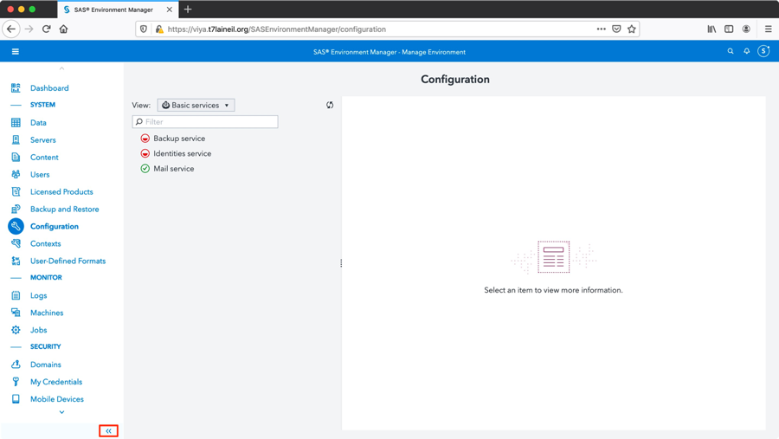

## 4.3 配置其他SAS Environment Manager管理者

以下範例為將sasdemo01及sasdemo02帳號加入SASEnvironmentManager管理者群組,

包含Application Administrators及SAS Administrators,

使用sasboot帳號登入SASEnvironmentManager



配置Application Administrators

進入管理環境設定Application Administrators

點選左側”使用者”=>“自訂群組”=> “Application Administrators”

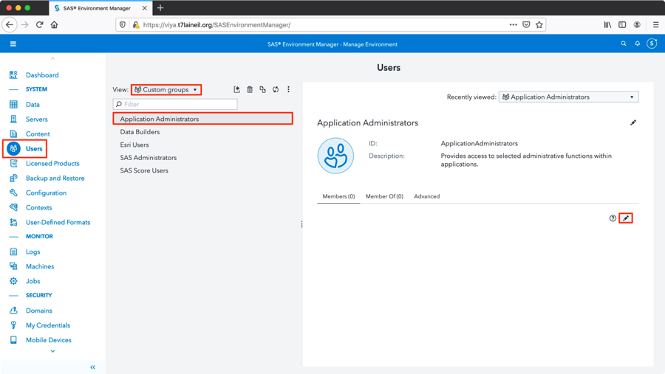

將欲加入之使用者拉到”選取的識別身份”, 點選”確定”

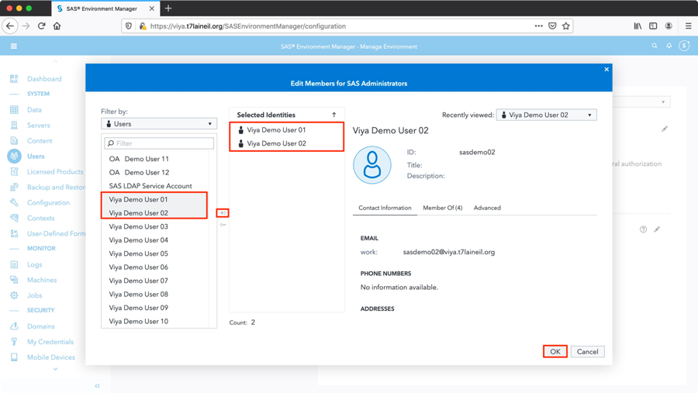

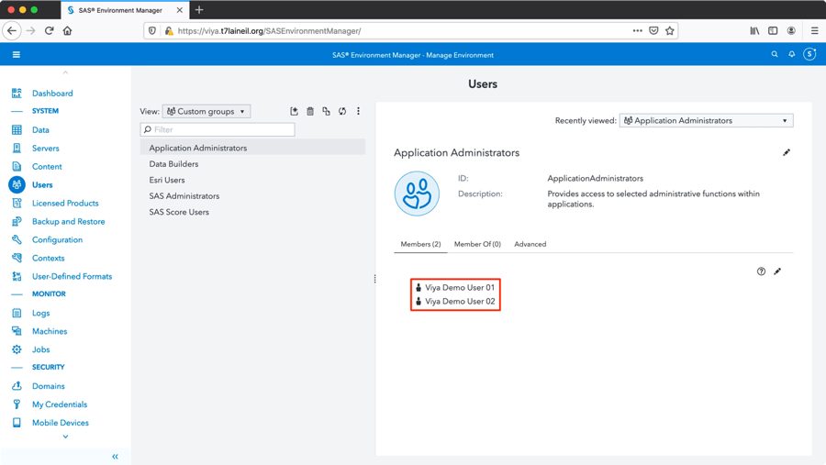

配置SAS Administrators

點選” SAS Administrators”

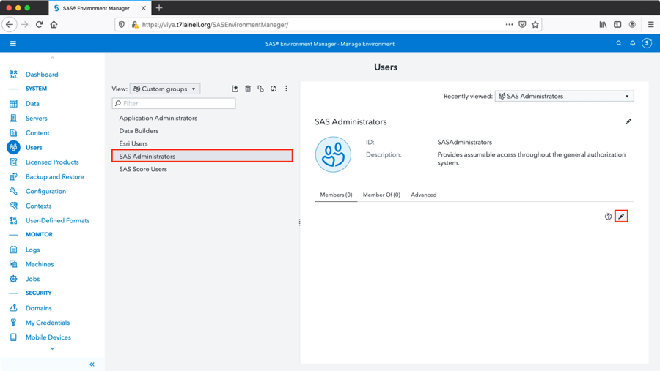

將欲加入之使用者拉到”選取的識別身份, 點選”確定”

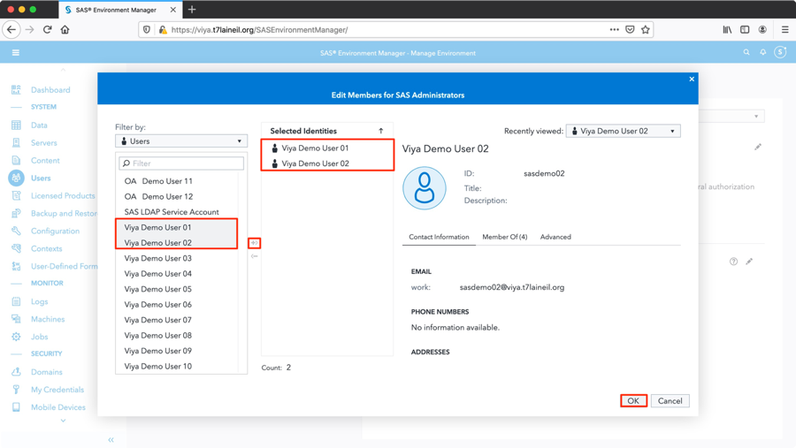

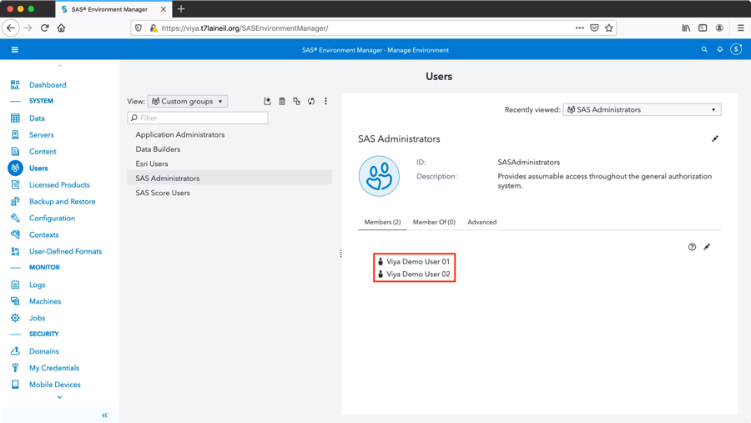

## 4.4 啟動SAS Viya可以使用X command

Contexts -> Compute contexts > SAS Studio compute context -> Edit -> Add Attributes

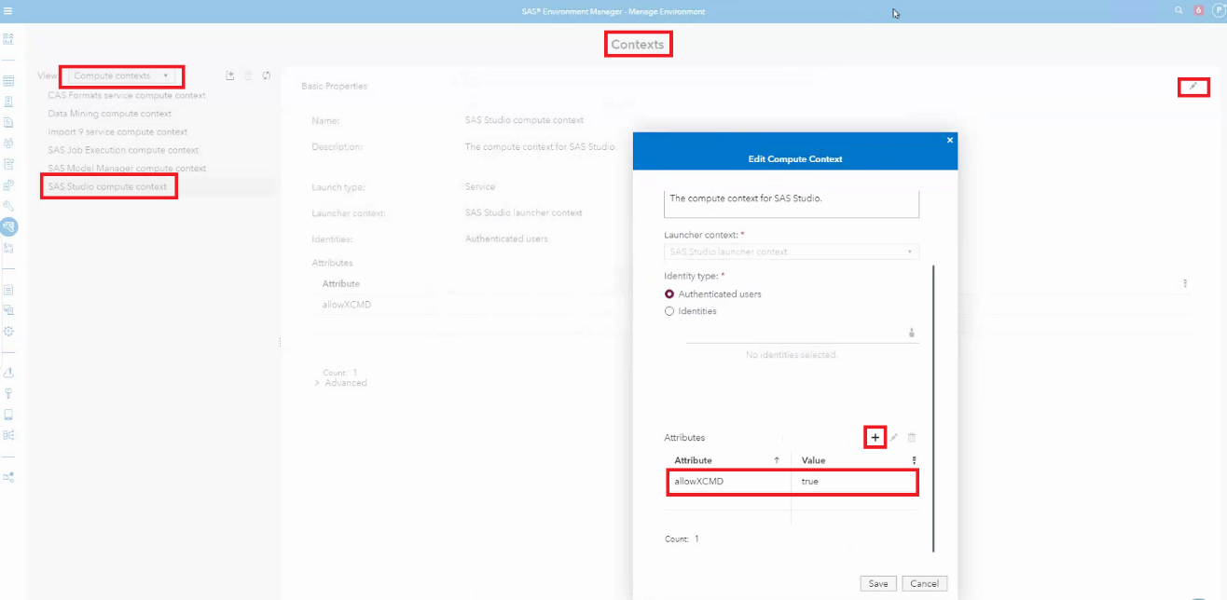

Add Attribute : allowXCMD, Value : true

Contexts -> Compute contexts > SAS Jon Execution compute context -> Edit -> Add Attributes

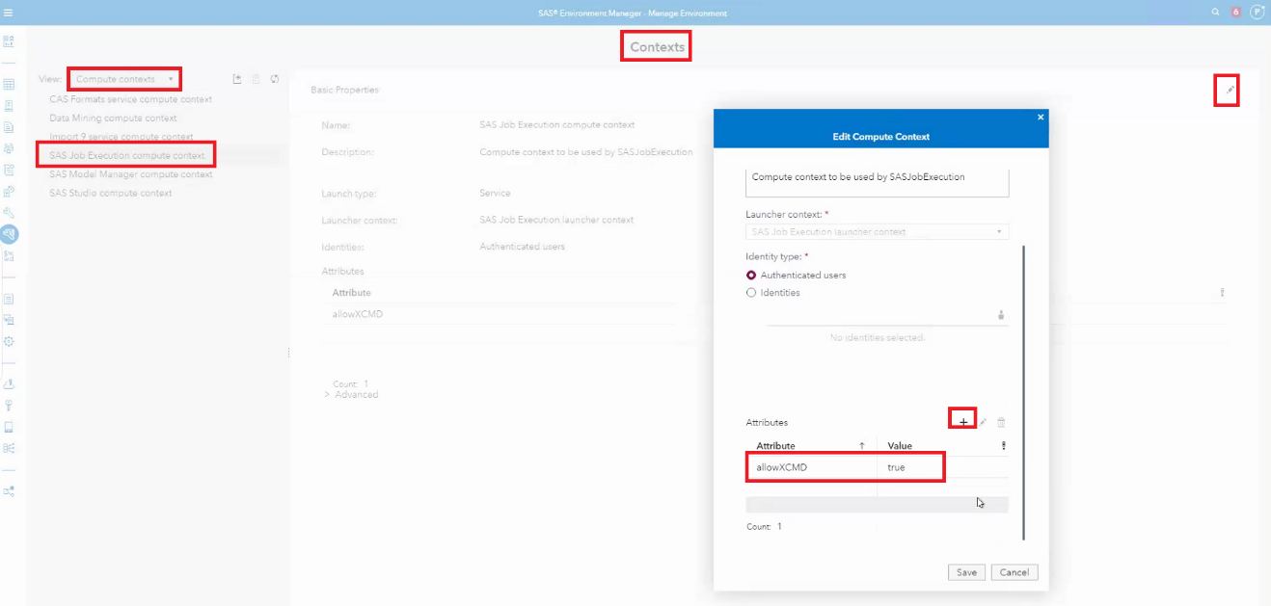

Add Attribute : allowXCMD, Value : true

## 4.5 設定Job execution service log 的 EXPIRATION

1: 登入SAS Environment Manager

2: Select ‘All Services’

3: Search ‘job’

4: Choose SAS Job Execution and edit ‘sas.jobexecapp’

5: expiration 輸入P7D

6: save

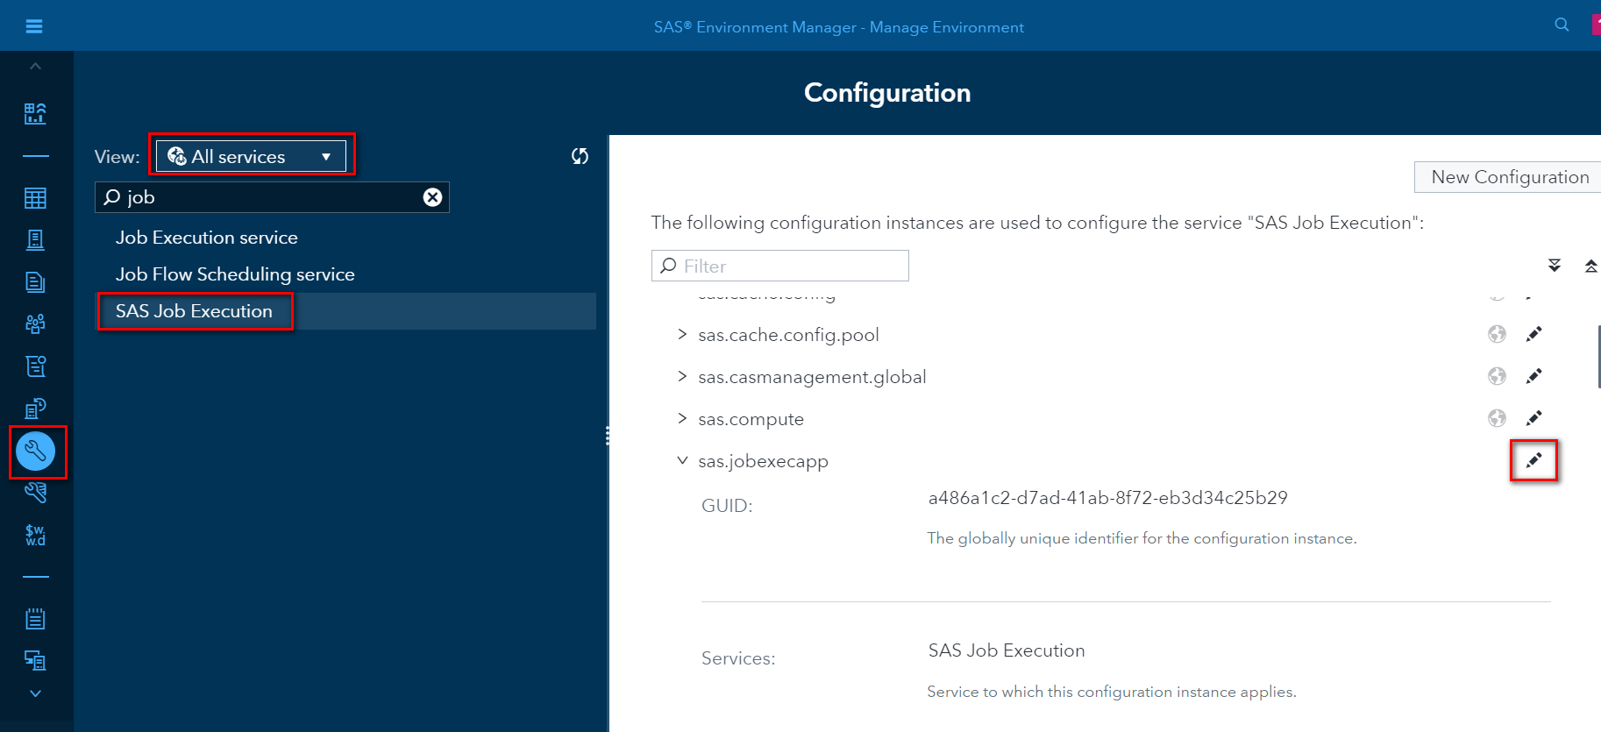

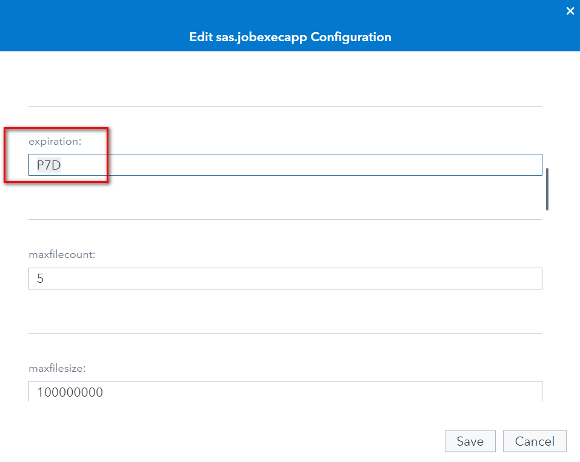

# **安裝後基本驗證**

## 驗證Admin帳號登入

[https://*[loadbalance_url]*/](https://[loadbalance_url]/)*SASEnvironmentManager*

登入SASEnvironmentManager,

開啟瀏覽器, 建議使用firefox 60 or later或chrome 73 or later,

輸入admin帳號及密碼登入

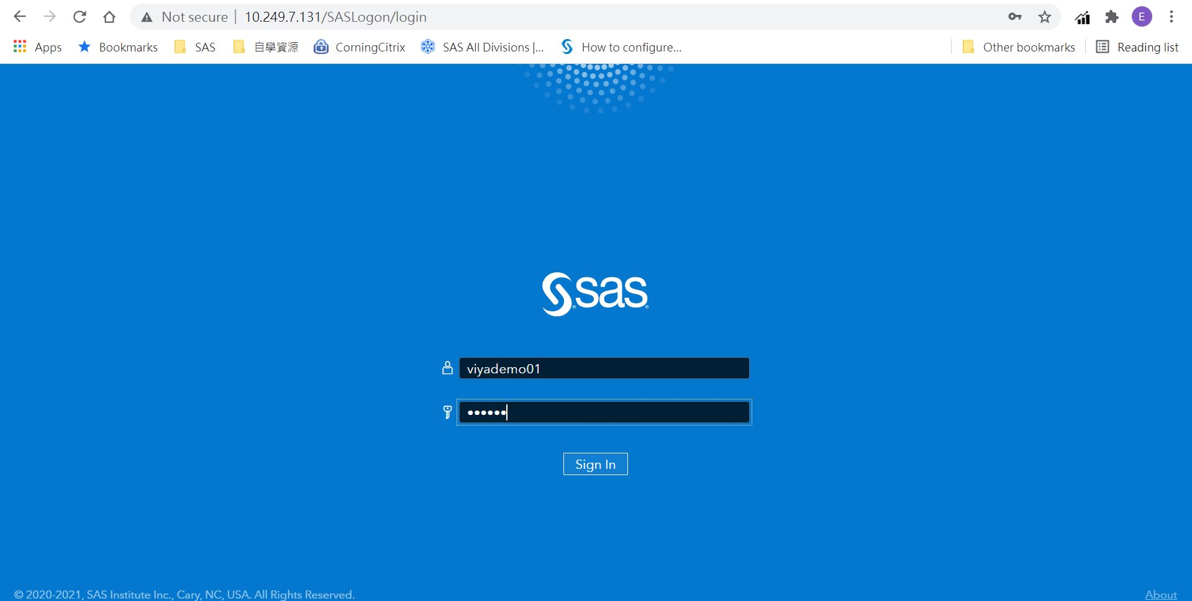

確認有跳出admin角色確認選項，選擇”Yes是”

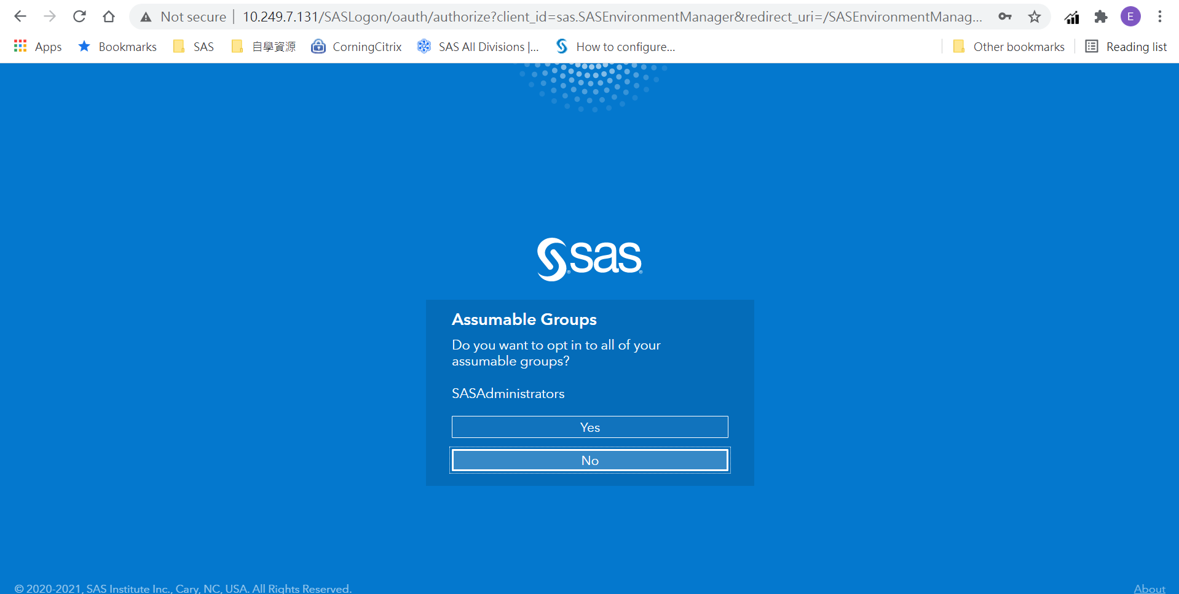

## 驗證SAS Viya Service狀態

登入後點選左側”儀表板”並確認服務狀態, 綠燈表示正常啟用

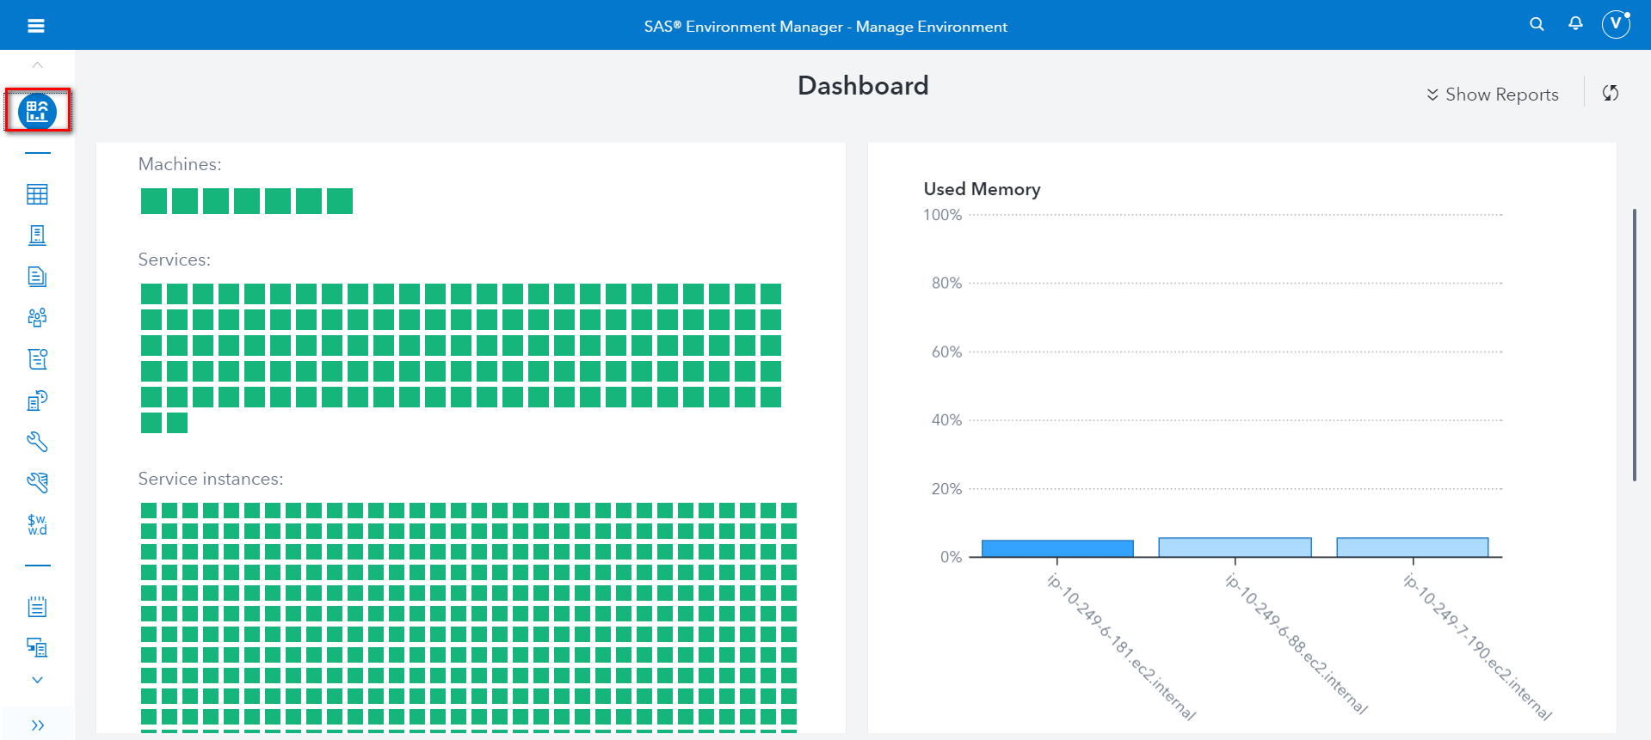

也可以透過執行指令的方式確認服務狀態

[control01]

|  |
| --- |
| [root@control01 ~]# ansible-playbook -i /CREPOS/viya35_src/sas_viya_playbook/inventory.ini /CREPOS/viya35_src/sas_viya_playbook/viya-ark/playbooks/viya-mmsu/viya-services-status.yml |

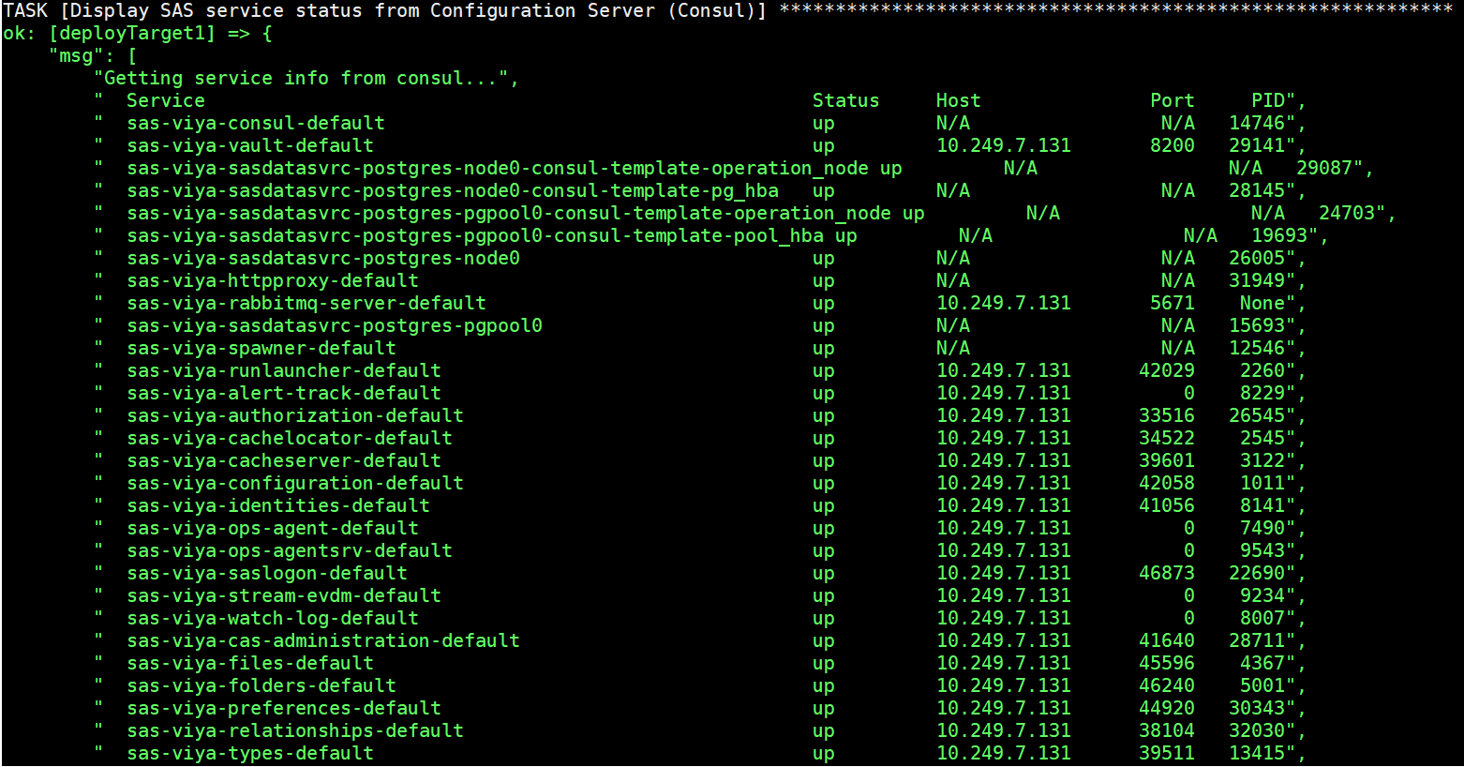

## 驗證SAS Viya版本

點選右上方帳號位置, 點選”關於”

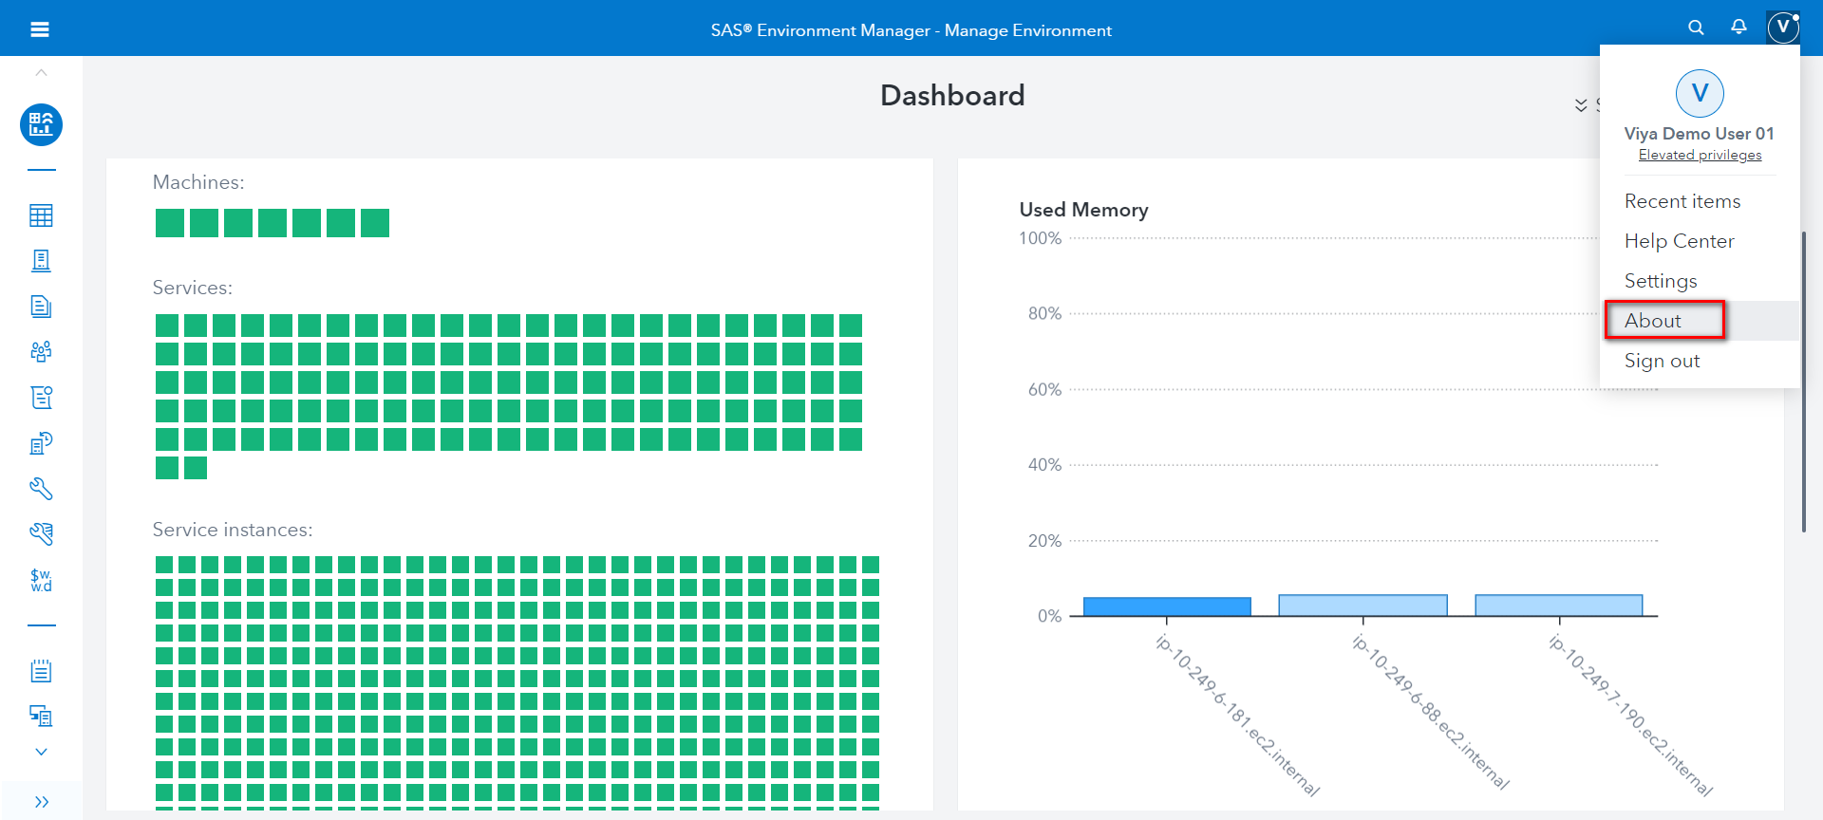

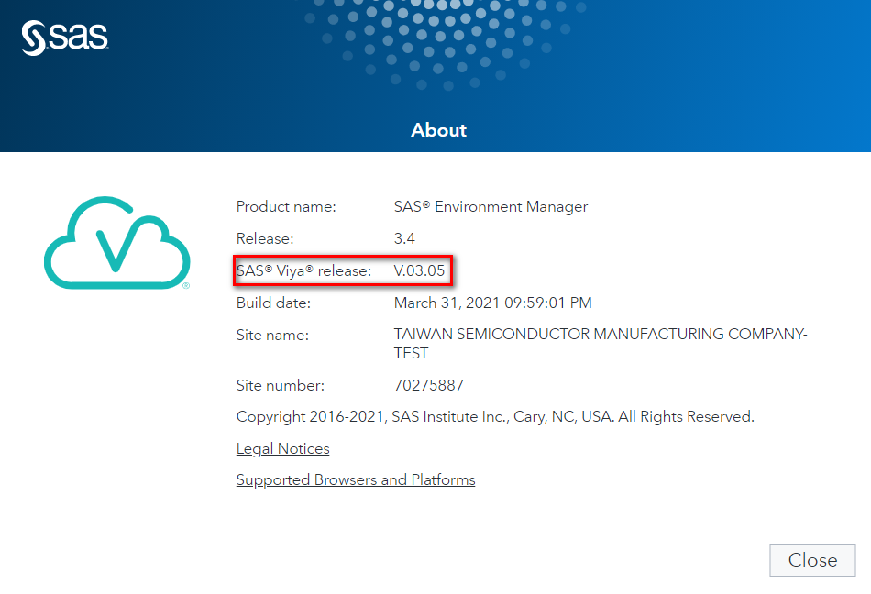

## 驗證 SAS License Product

點選左側”授權產品”, 確認”產品”授權及”到期日期”

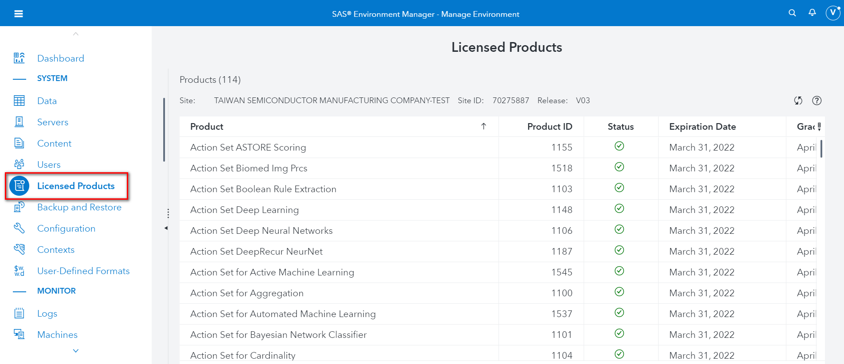

## 驗證SAS 備份功能

使用SASEnvironmentManager管理者登入

點選左側”組態”, 點選”Backup service”

確認shareVault path

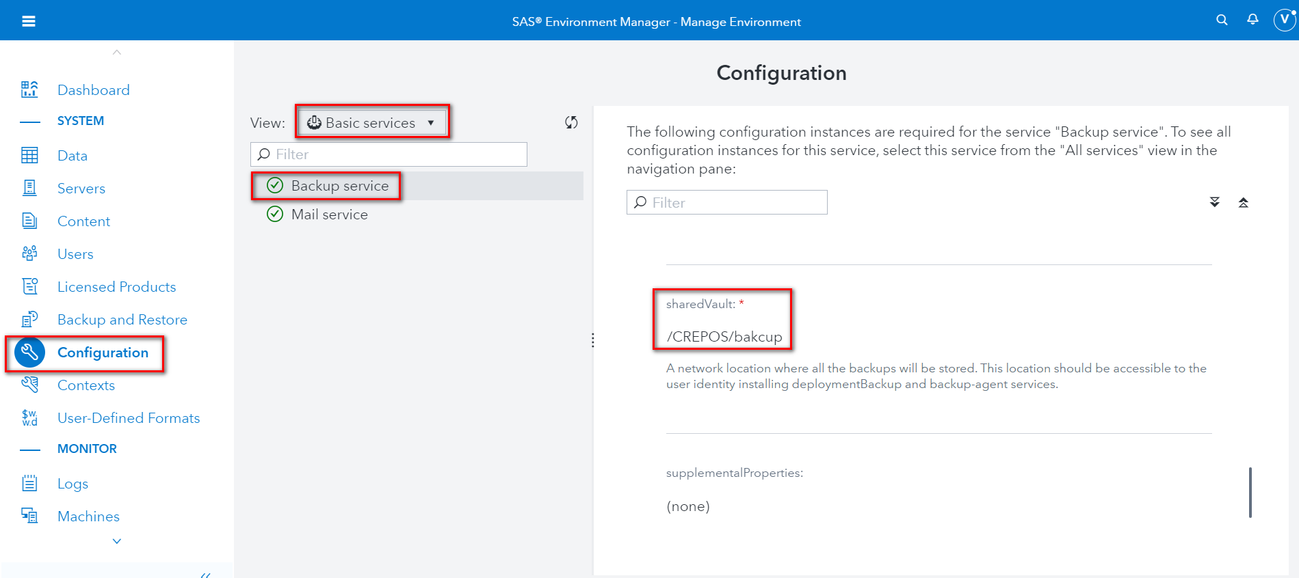

點選左側”備份和還原”

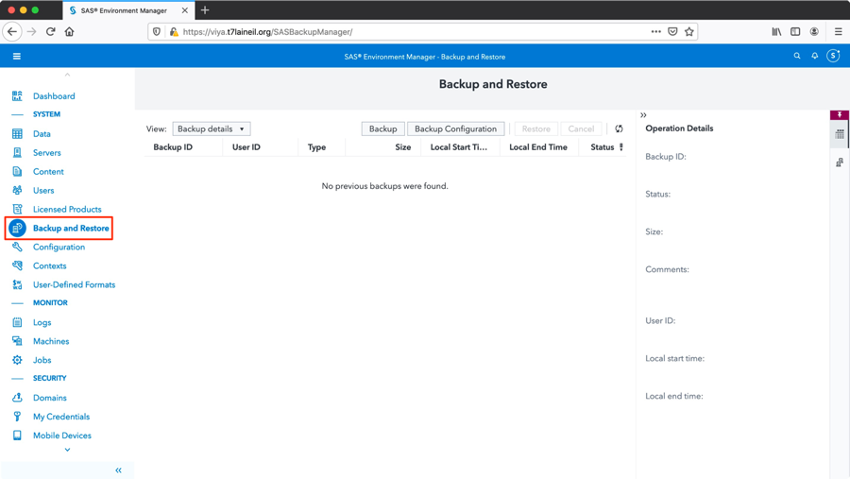

點選”備份”-Default

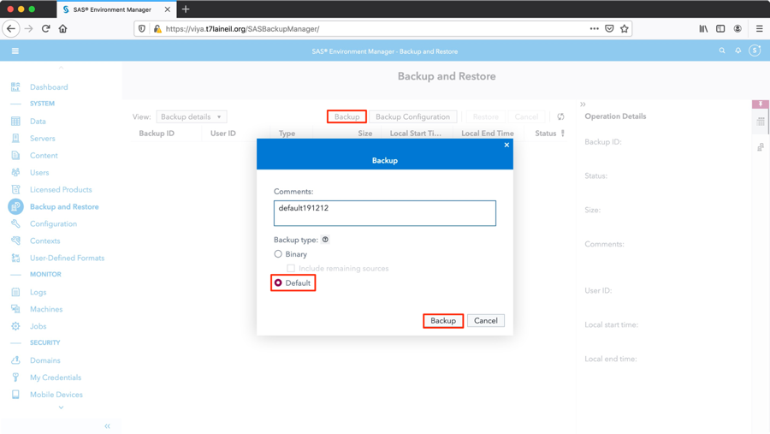



點選”備份”-Binary

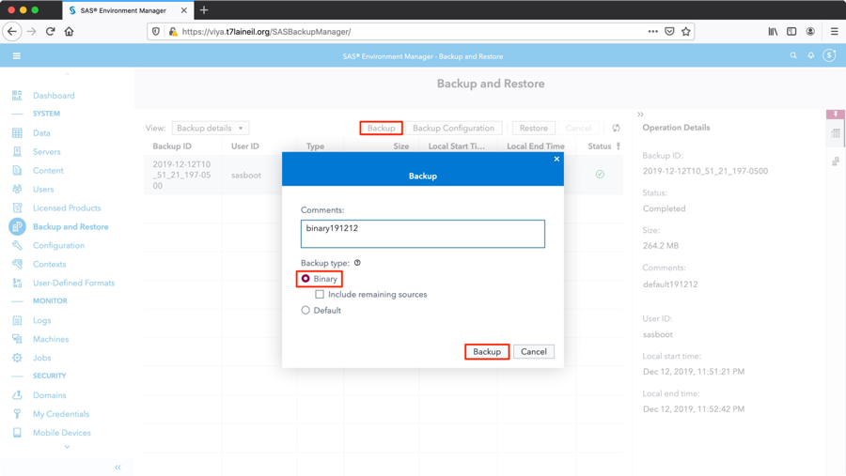

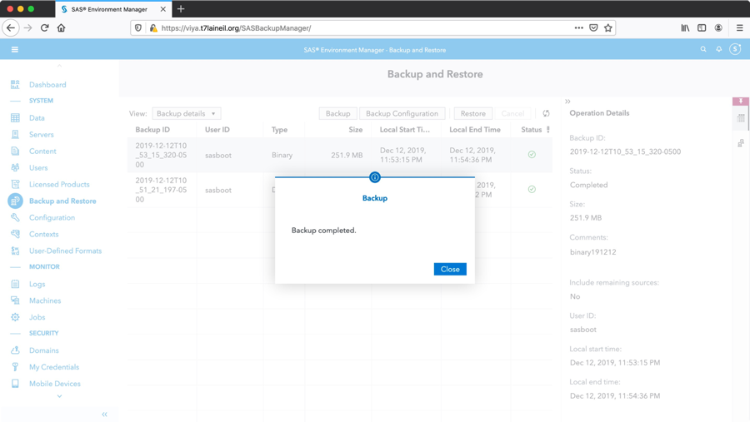

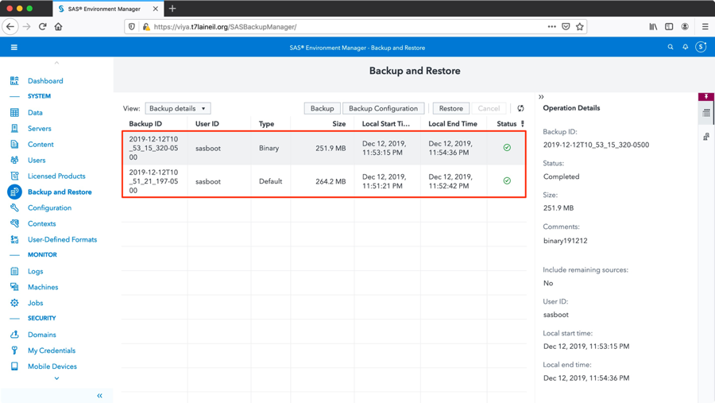

驗證Backup service

|  |
| --- |
| [root@micro01~]# ls -l /CREPOS/viyabackup/  [root@micro01~]# du -sh /CREPOS/viyabackup/ |

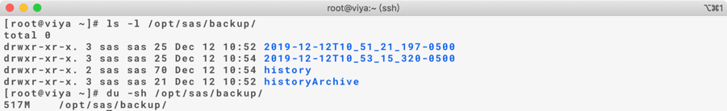

## 驗證CAS相關設定

## 5.6.1 驗證CAS_ENABLE_CONSUL_RESOURCE_MANAGEMENT設定

使用SASEnvironmentManager管理者登入

點選左側”Server”, 選擇cas-shared-default -> ‘Configuration’

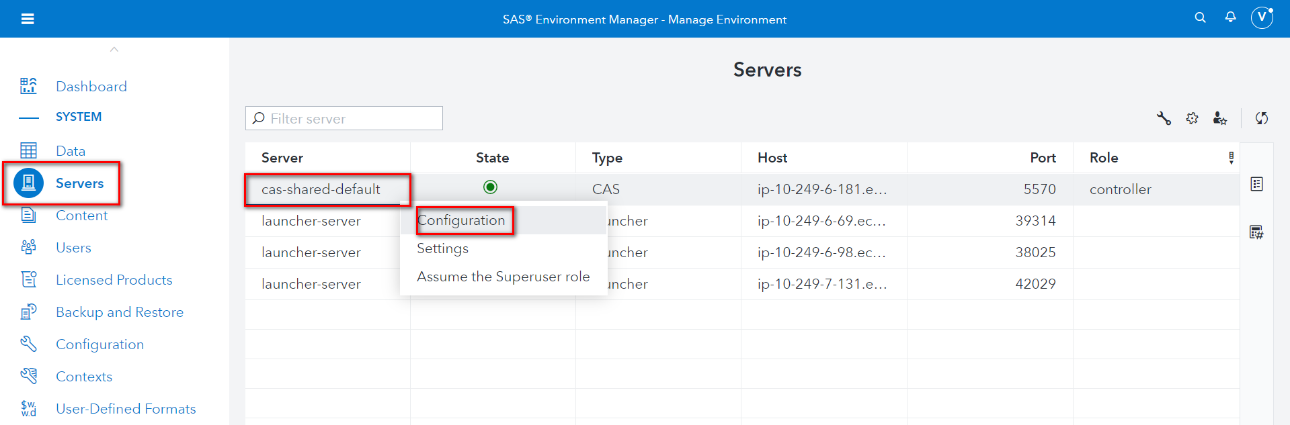

點選node -> 選擇controller ->選擇Runtime environment

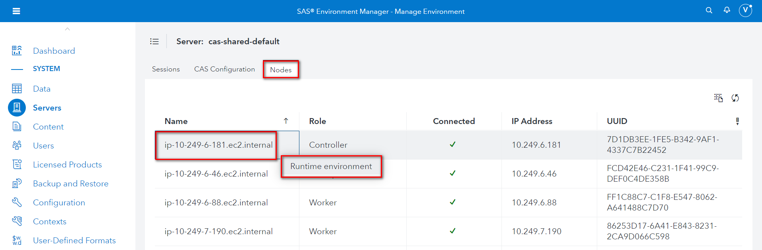

確認設定值CAS_ENABLE_CONSUL_RESOURCE_MANAGEMENT為True

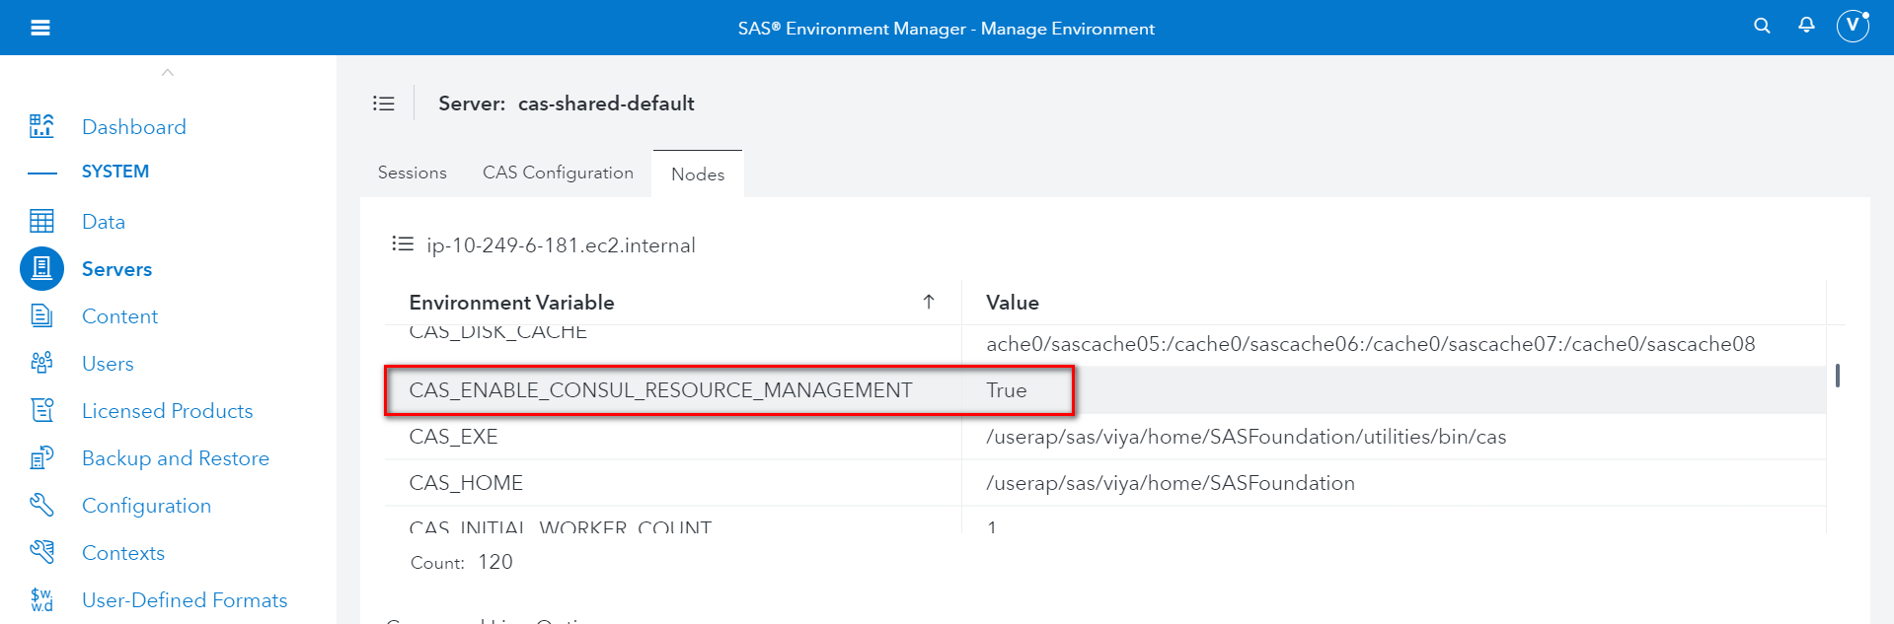

## 5.6.2 驗證SERVICESBASEURL與MAXTABLEMEM

使用SASEnvironmentManager管理者登入

點選左側”Server”, 選擇cas-shared-default -> ‘Configuration’



確認SERVICESBASEURL與MAXTABLEMEM設定

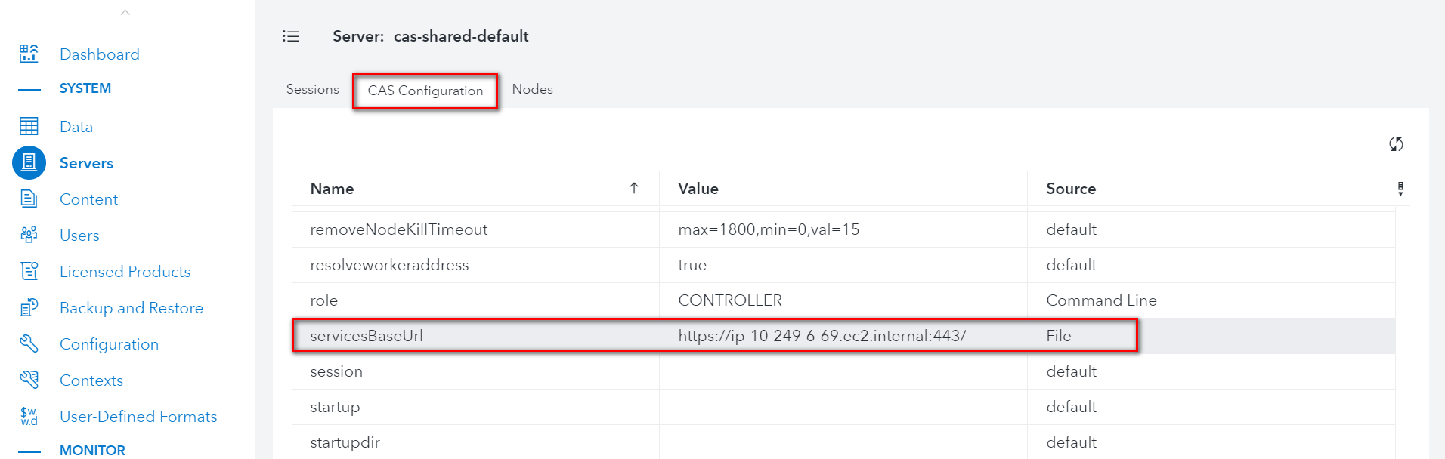

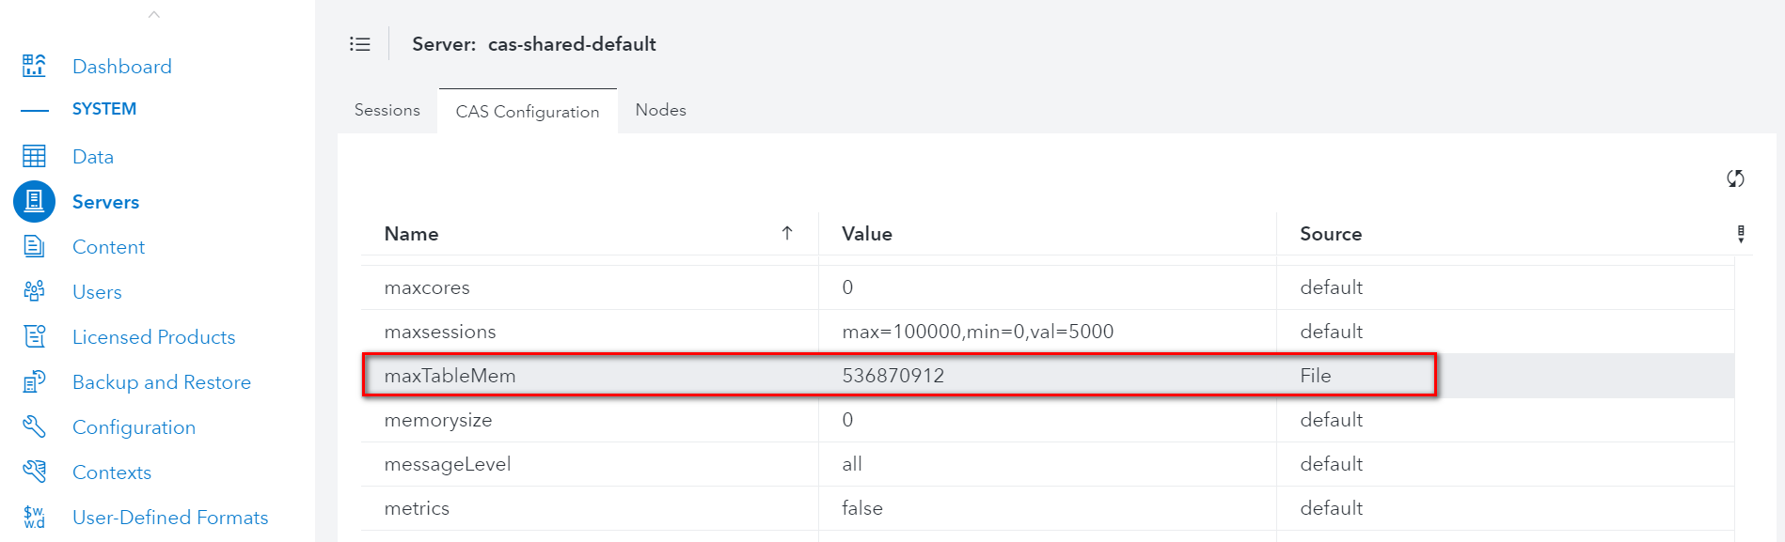

## 5.6.3 驗證sas workspace 位置

登入https://[load balance url]/SASStudioV

輸入下列sas程式碼

|  |
| --- |
| proc options option=work;  run; |

確認sas workspace位置

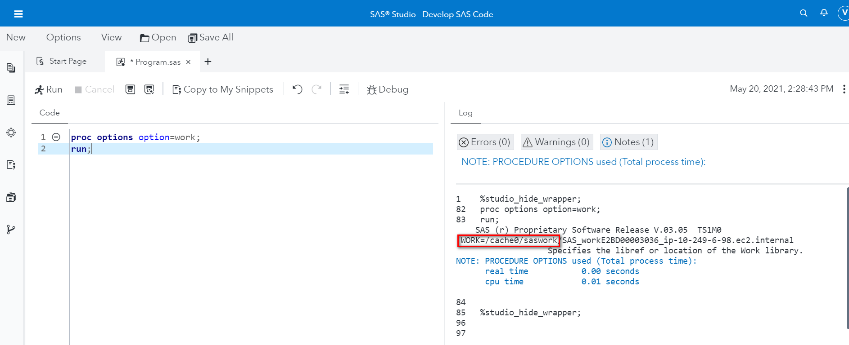

## 5.7 驗證Apache Timeout設定

[control01]

Check timeout on all microservice servers

|  |
| --- |
| #ansible microservice -m shell -a "cat /etc/httpd/conf.d/petrichor.conf | grep Timeout" |

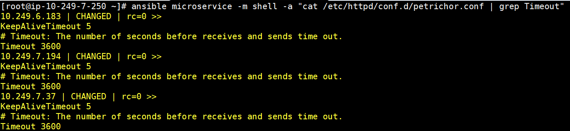

## 5.8 驗證cmdui設定

[control01]

Check sas-ops-agentclt on all node

|  |
| --- |
| #ansible cluster -m shell -a "ps -ef | grep ops-agent| grep cmdui | grep -v grep | grep -v ansible" |

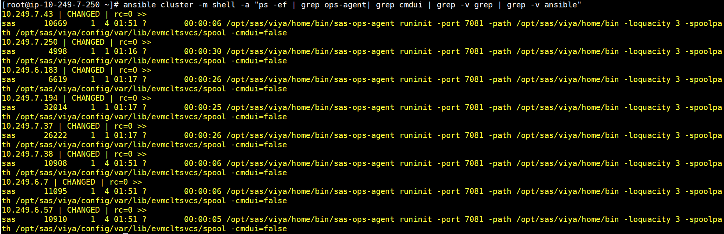

[micro01]

Check sas-ops-agentsrv on micro 01

|  |
| --- |
| #cat /opt/sas/viya/home/bin/sas-ops-agentsrv | grep cmdui |



## 5.9 驗證dirty ratio設定

[control01]

Check dirty ration on all node

|  |
| --- |
| # ansible cluster -m shell -a "cat /etc/sysctl.conf | grep dirty" |

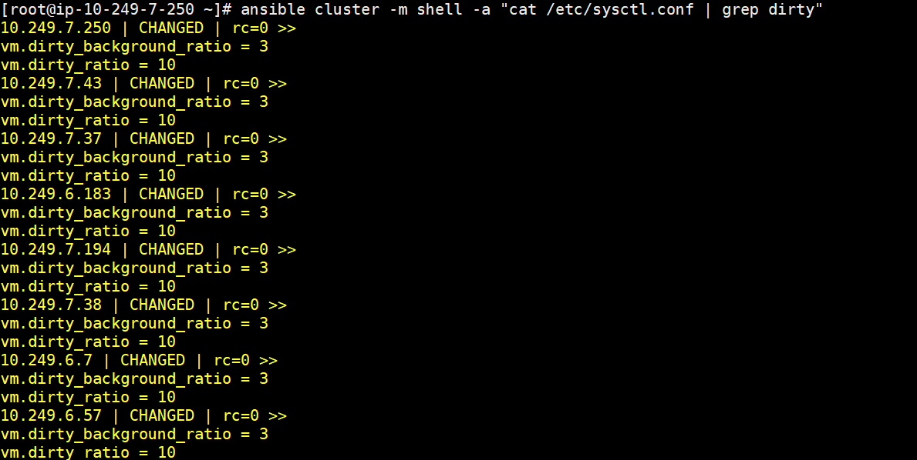

## 5.10 驗證TKPHAT(trace worker lost使用)

[control01]

Check TKPHAT on all cas nodes

|  |
| --- |
| # ansible cas -m shell -a "cat /opt/sas/viya/config/etc/cas/default/cas_usermods.settings | grep TKPHAT" |

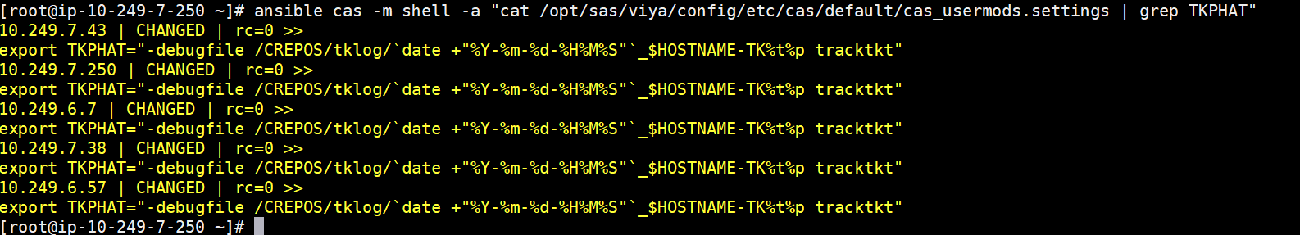

## 5.11 驗證SAS Viya常用Service的Log Level

**檢查Job Execution Service Log level by SAS Environment Manager**

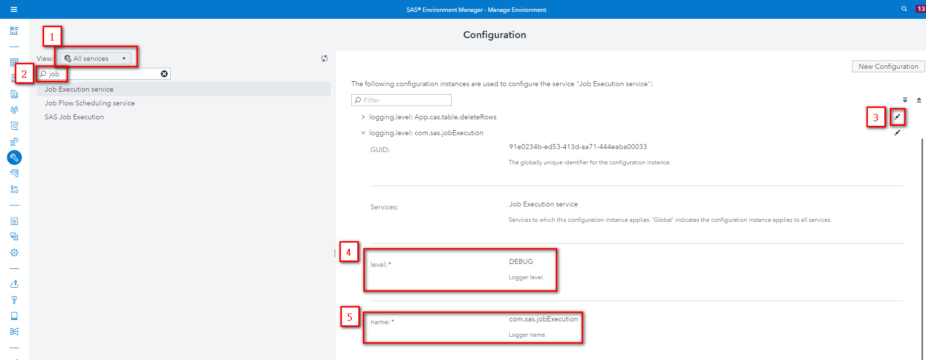

1: Select ‘All Services’

2: Search ‘job’

3: Choose Job Execution service and 打開’logging.level:com.sas.jobExecution’

4: 檢查 level = ‘DEBUG’

5: 檢查 name = ‘com.sas.jobExecution’

**檢查Job Flow Scheduling Service Log level by SAS Environment Manager**

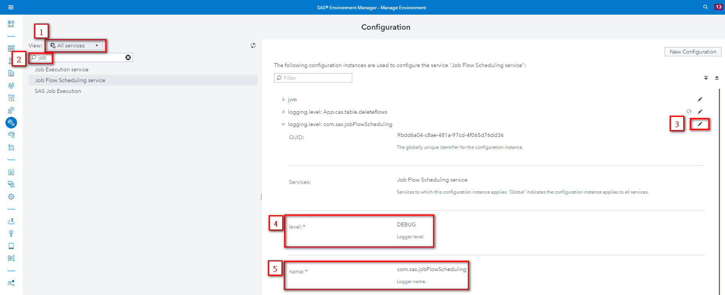

1: Select ‘All Services’

2: Search ‘job’

3: Choose Job Flow Scheduling service and 展開’ logging.level: com.sas.jobFlowScheduling’

4: 檢查 level = ‘DEBUG’

5: 檢查 name = ‘com.sas.jobFlowScheduling’

**檢查SAS Job Execution Service Log level by SAS Environment Manager**

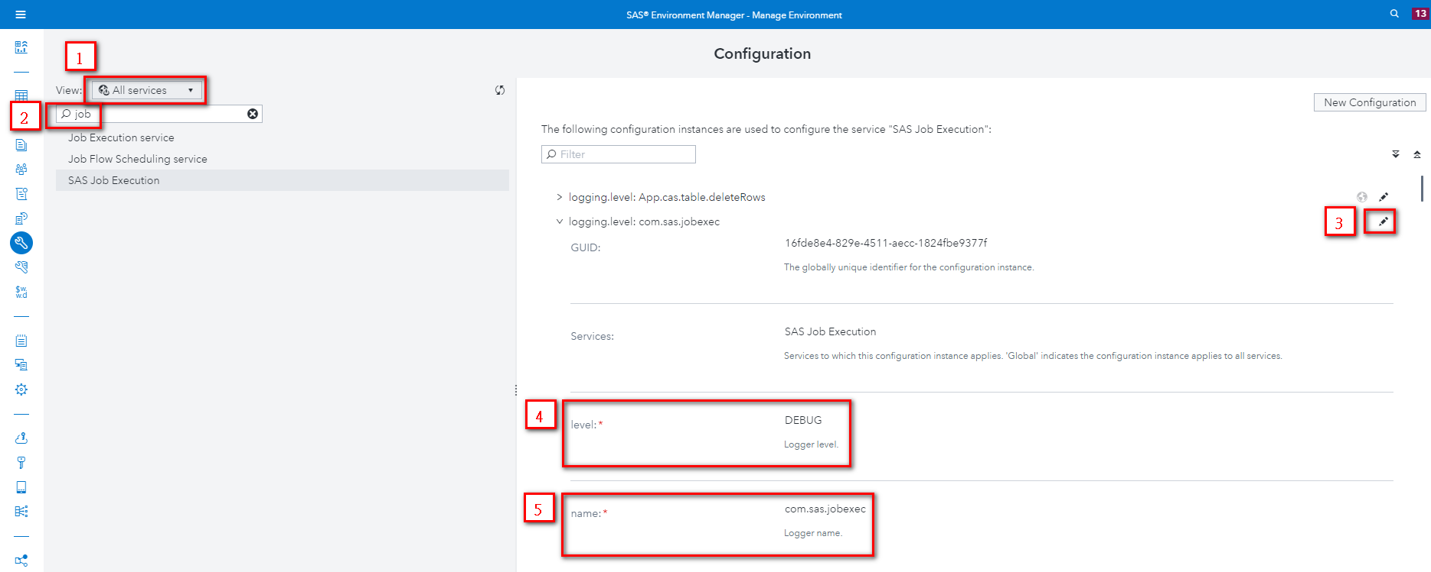

1: Select ‘All Services’

2: Search ‘job’

3: Choose SAS Job Execution and 展開’ logging.level: com.sas.jobexec’

4: 檢查 level = ‘DEBUG’

5: 檢查 name = ‘com.sas.jobexec’

**檢查Schedule service Log Level by SAS Environment Manager**

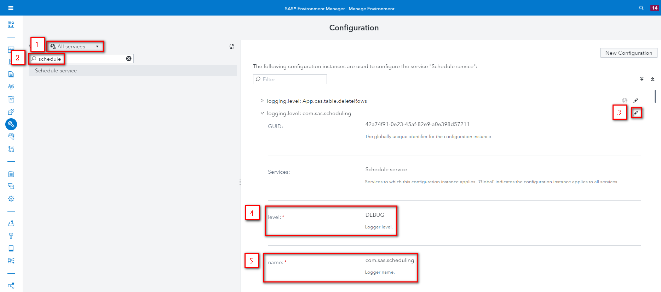

1: Select ‘All Services’

2: Search ‘schedule’

3: Choose Schedule service and 展開’logging.level: com.sas.scheduling’

4: 檢查 level = ‘DEBUG’

5: 檢查 name = ‘com.sas.scheduling’

**檢查Compute service Log Level by SAS Environment Manager**

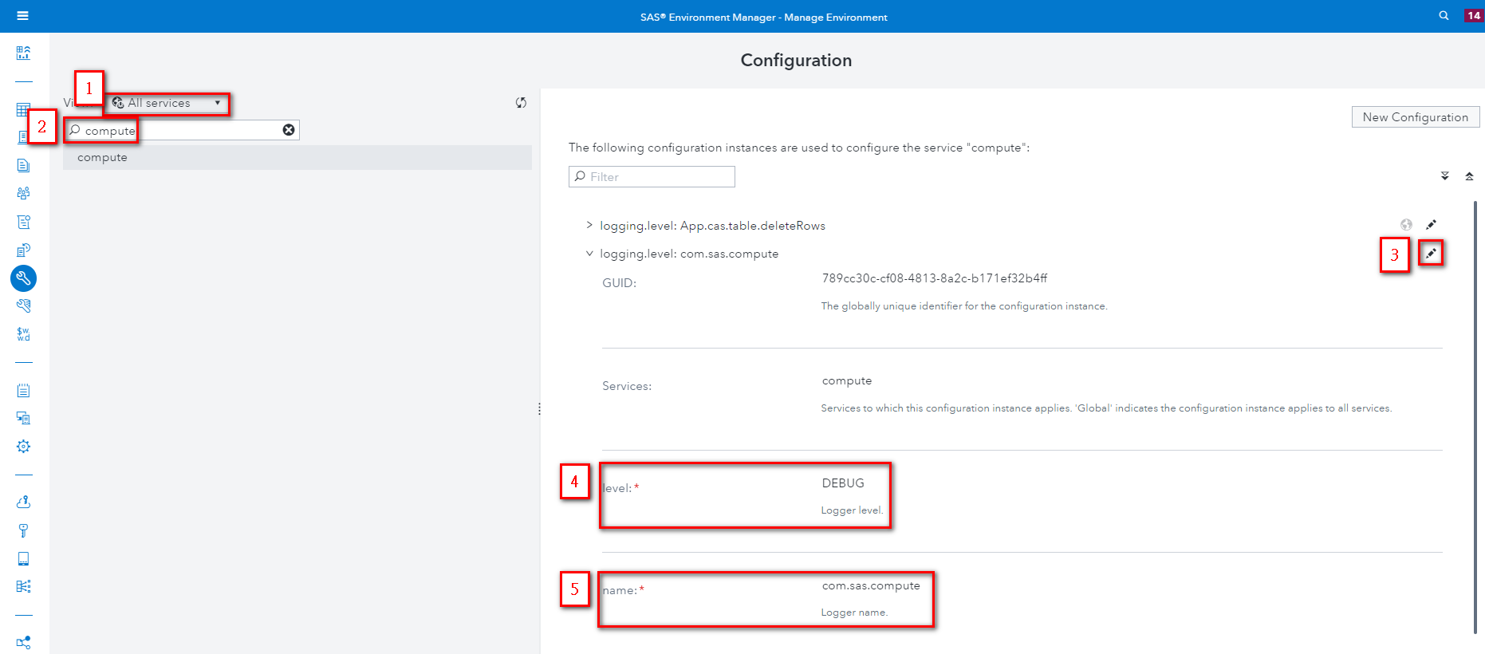

1: Select ‘All Services’

2: Search ‘compute’

3: Choose compute service and 展開‘logging.level: com.sas.compute’

4: 檢查 level = ‘DEBUG’

5: 檢查 name = ‘com.sas.compute’

## 5.12 驗證Enable dir creation for AD user

**檢查SAS Launcher Server & SAS Copmute Server**

檢查 Laurcher Server & Compute Server Configuration

[control01]

|  |
| --- |
| [root@control01 ~]# source /opt/sas/viya/config/consul.conf  [root@control01 ~]# /opt/sas/viya/home/bin/sas-bootstrap-config --token-file /opt/sas/viya/config/etc/SASSecurityCertificateFramework/tokens/consul/default/client.token kv read config/launcher-server/global/environment/SASMAKEHOMEDIR |



**檢查SAS Object Spawner**

檢查 all microservice servers的Object Spawner Server Configuration

[control01]

|  |
| --- |
| [root@control01 ~]# ansible microservice -m shell -a "cat /opt/sas/viya/config/etc/spawner/default/spawner_usermods.sh | grep SASMAKEHOMEDIR" |



**檢查SAS Cloud Analytic Services**

檢查cas primary and backup controller的 Cloud Analytic Services 設定

[control01]

|  |
| --- |
| [root@control01 ~]# ansible controller -m shell -a "cat /opt/sas/viya/config/etc/cas/default/casconfig_usermods.lua" |

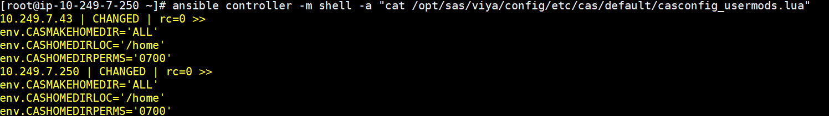

## 5.13 驗證EG連線

檢查all microservice servers的Object Spawner Server Configuration SSL設定

[control01]

|  |
| --- |
| [root@control01 ~]# ansible microservice -m shell -a "cat /opt/sas/viya/config/etc/spawner/default/spawner_usermods.sh | grep ssl" |

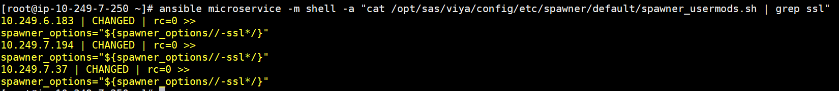

EG Client安裝憑證與連線測試

參照下面附檔進行EG client憑證安裝與連線測試



連線成功畫面如下

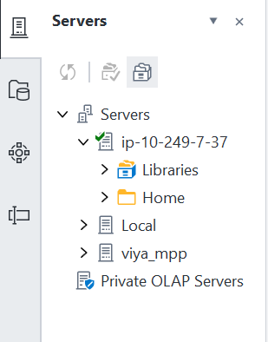

## 5.14 驗證SASStudioV和compute service heap size

檢查SAS StudioV Initial Heap Size and Maximum Heap size

登入SAS Environment Manager -> Configuration -> select All services > SAS Studio Viya -> New Configuration -> select jvm

java_option_xms =-Xms4096m

java_option_xmx =-Xmx4096m

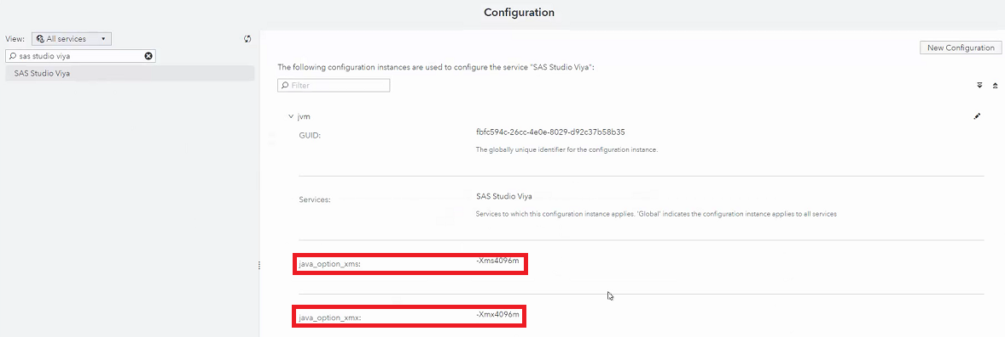

檢查SAS Compute service Maximum Heap size :

登入SAS Environment Manager -> Configuration -> select All services > Compute -> New Configuration -> select jvm

java_option_xmx =-Xmx4096m

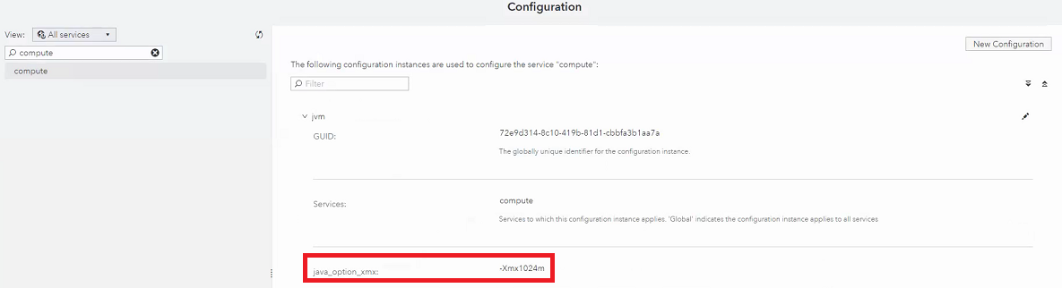

登入任意microservice node

vi /var/log/sas/viya/studiov/default/sas-studiov-_yyyy-MM-dd_hh-mm-ss.log可檢查

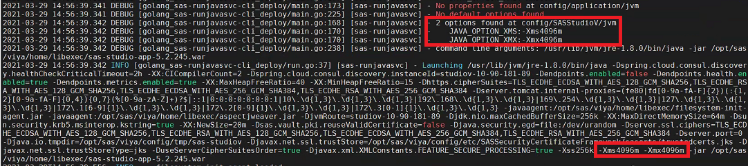

vi /var/log/sas/viya/compute/default/sas-compute-_yyyy-MM-dd_hh-mm-ss.log可檢查

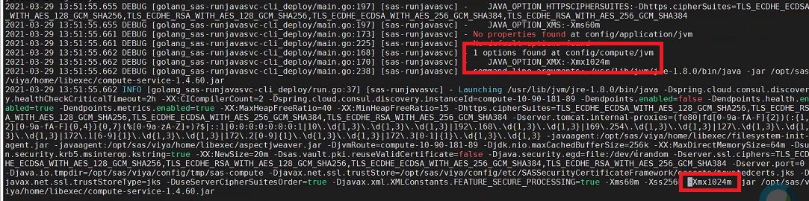

## 5.15 驗證Cgroup

檢查cgroup policy

[control01]

|  |
| --- |
| #/opt/sas/viya/home/bin/sas-admin auth login -u viyademo01 -p demopw  #/opt/sas/viya/home/bin/sas-admin cas servers policies list --all --server cas-shared-default |

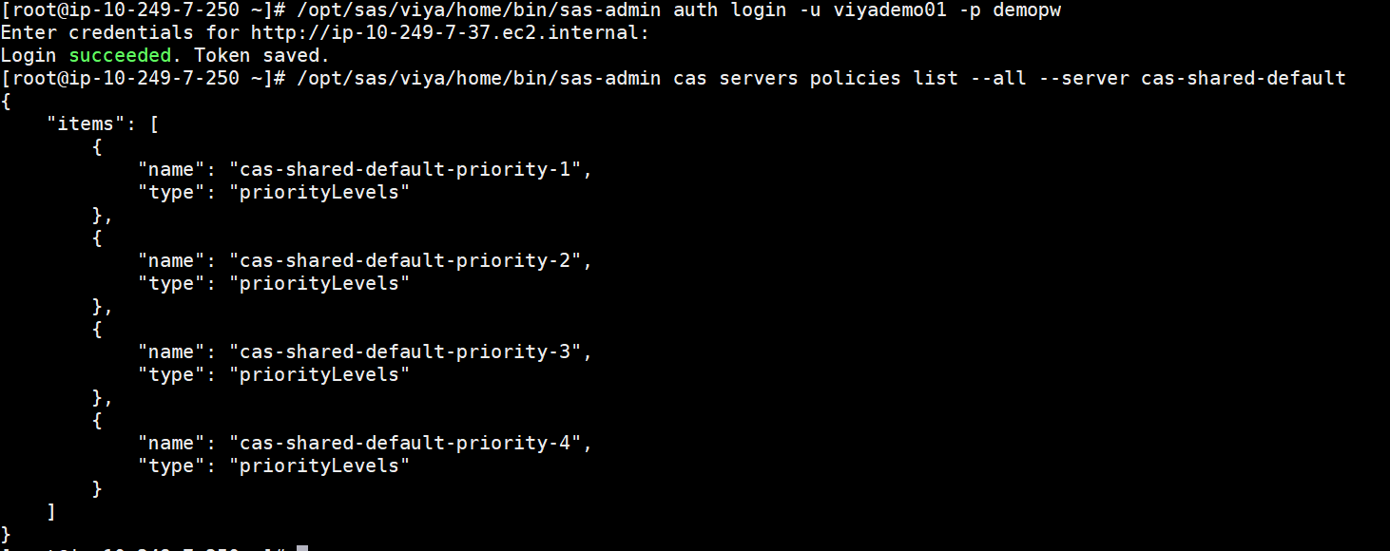

*Note: Cgroup於SAS Environment Manager -> Users -> Custom group的設定, 執行完Restore之後會回線

## 5.16 驗證OracleDB連線

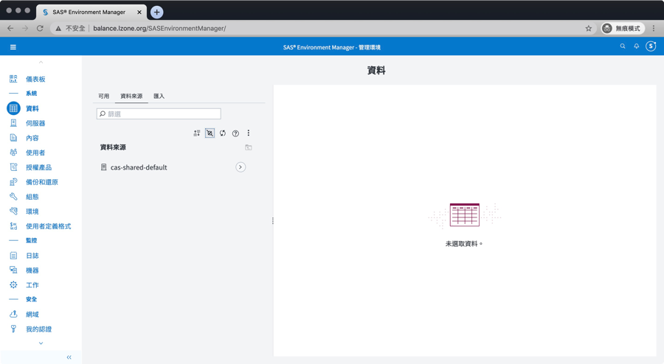

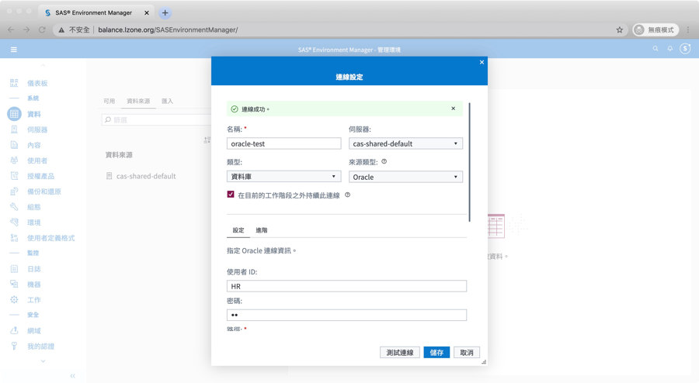

## 5.17 驗證SAS StudioV功能

SAS StudioV需使用AD或LDAP帳號登入, 且需整合Linux

需先完成 3.7.5 Linux加入AD網域

開啟瀏覽器, 建議使用firefox或chrome,

此處使用firefox為例, 輸入下方url,

[http://*[loadbalance_url]*/SASStudioV](http://[loadbalance_url]/SASStudioV),

使用AD帳號登入, 此範例使用viyademo01, 密碼為demopw

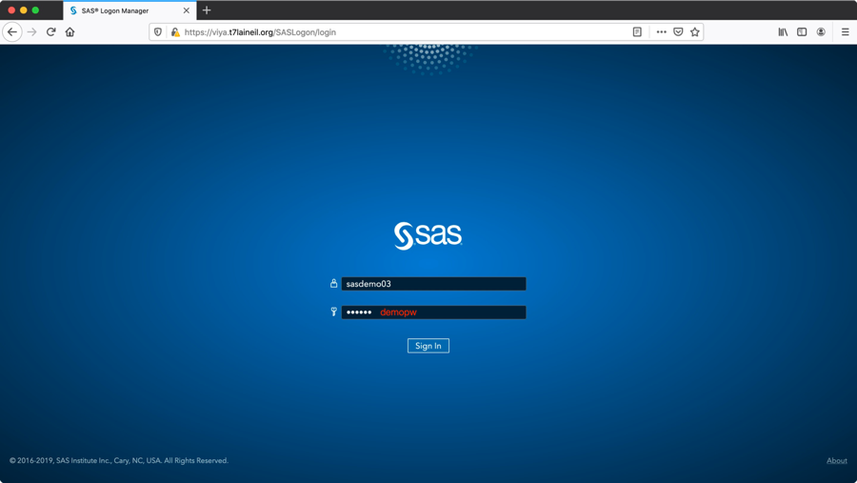

選擇主題設定或略過

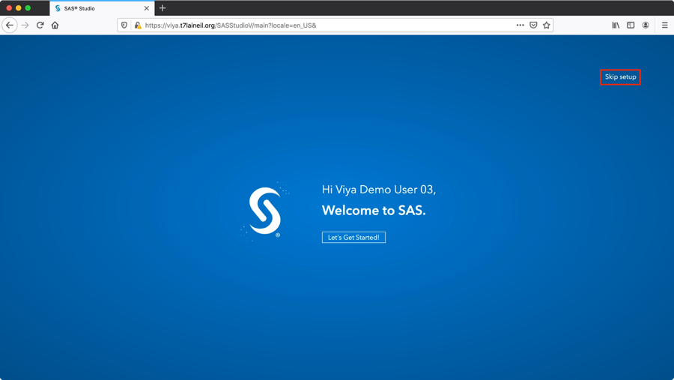

SASStudioV預設登入畫面



點選左側”程式碼片段”, 點選”SAS Viya Cloud Analytic Services”, 點選”建立cas連線”

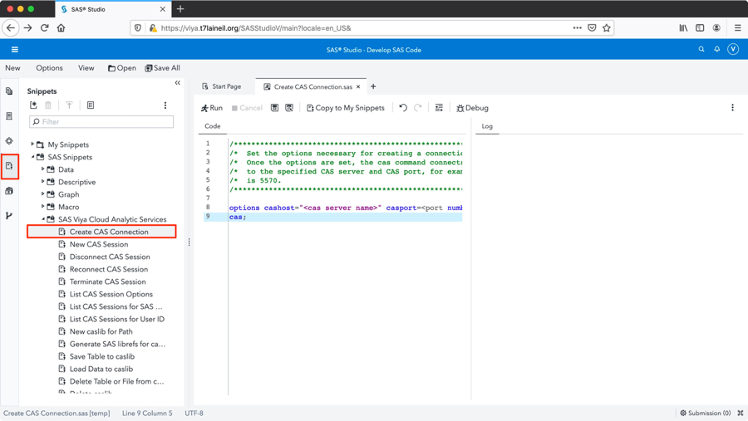

修改cashost為cas primary主機位置及port(預設為5570)並點選上方, 並確認執行成功

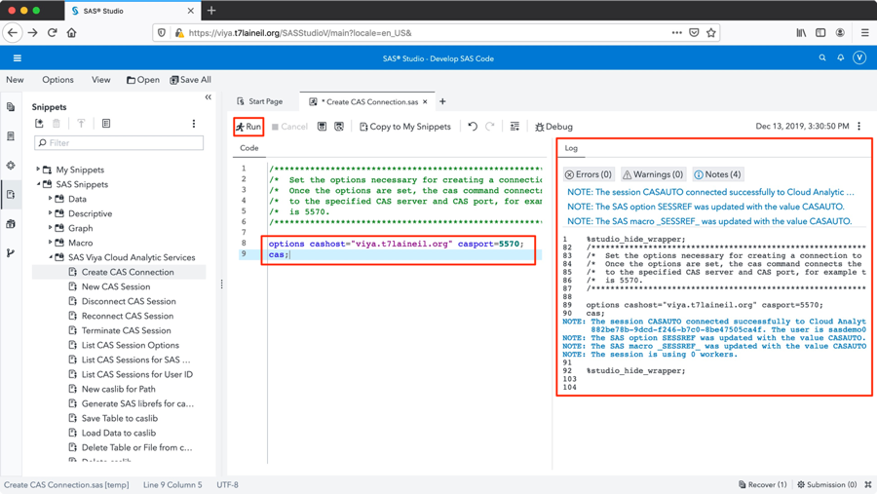

# **Viya服務管理**

此章節預設節點為control01, 目錄為sas_viya_playbook所在目錄,

此範例為/CREPOS/viya_35c/sas_viya_playbook,

透過viya-ark tools管理Viya服務

## 查詢Viya服務狀態

此方式需在sas-consul服務為啟動時使用

|  |
| --- |
| [root@control01 sas_viya_playbook]# ansible-playbook -i inventory.ini viya-ark/playbooks/viya-mmsu/viya-services-status.yml |

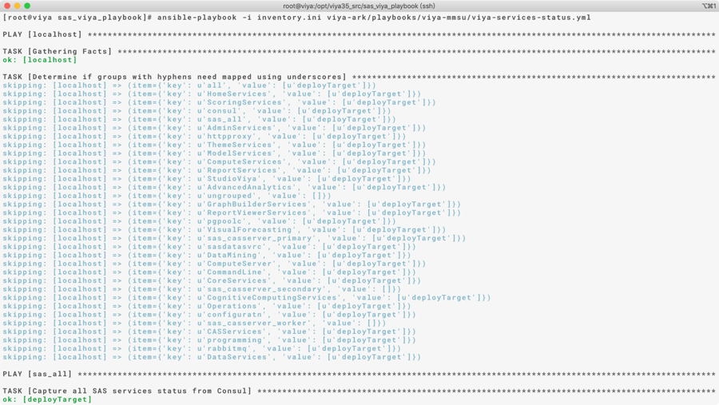

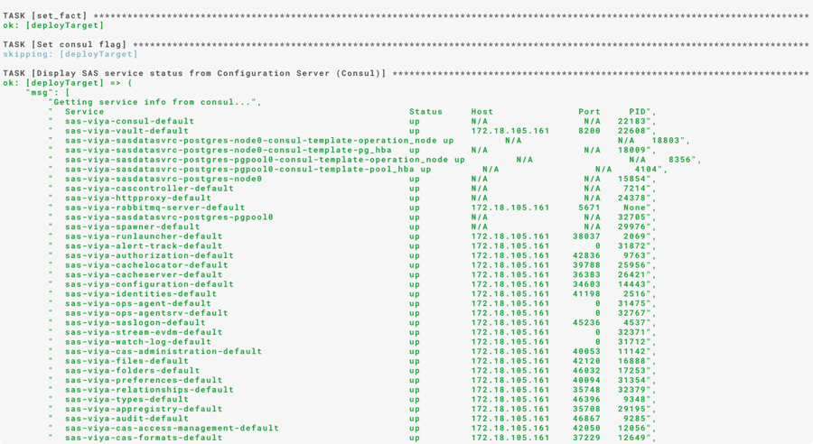

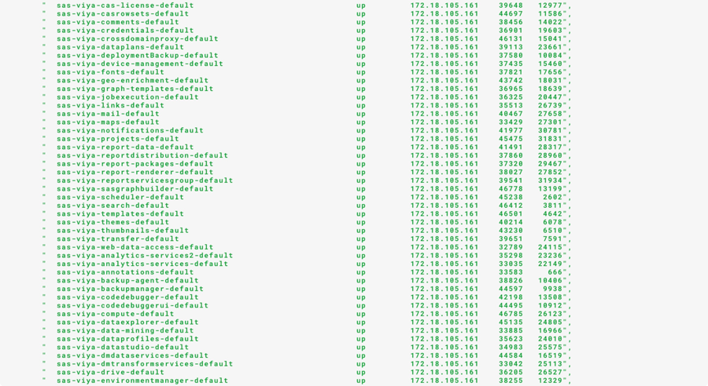

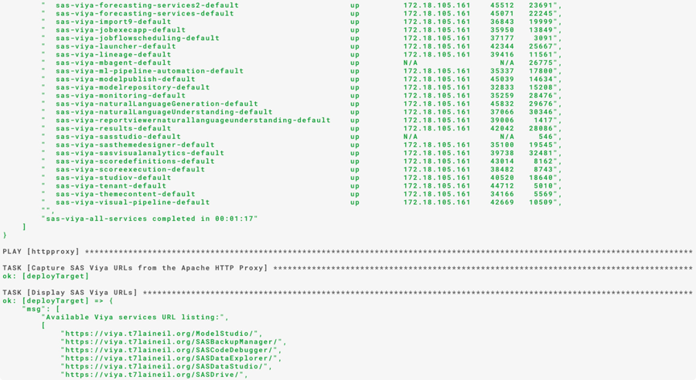

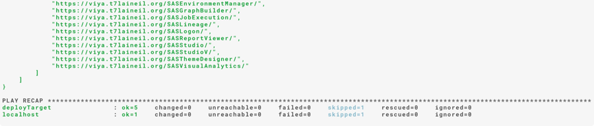

## 關閉Viya所有服務

如有停機需求, 停機前須先將所有服務關閉

|  |
| --- |
| [root@control01 sas_viya_playbook]# ansible-playbook -i inventory.ini viya-ark/playbooks/viya-mmsu/viya-services-stop.yml |

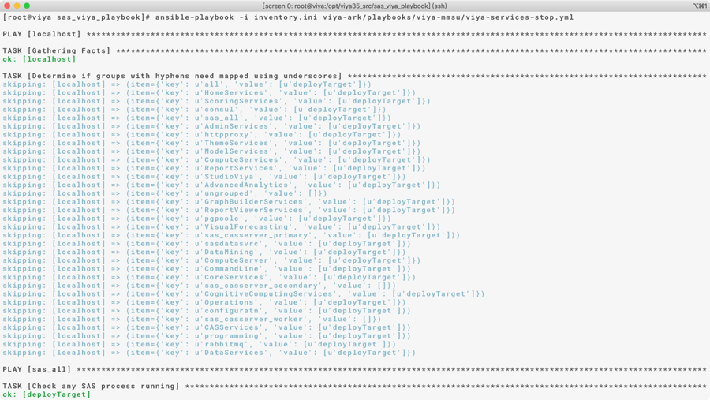

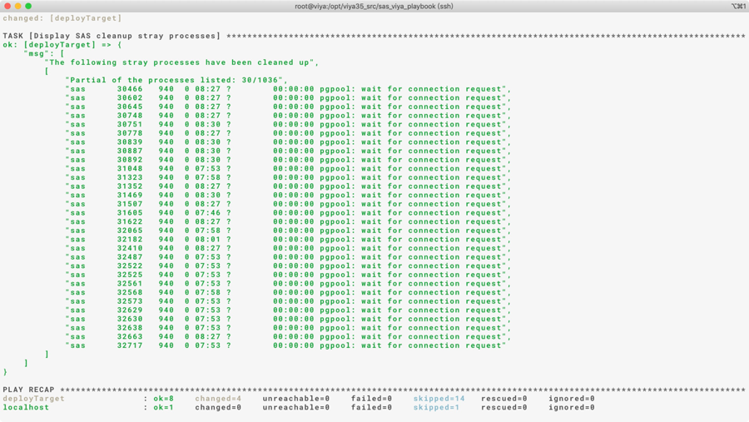

## 開啟Viya所有服務

重開機後需手動開啟所有服務

|  |
| --- |
| [root@control01 sas_viya_playbook]# ansible-playbook -i inventory.ini viya-ark/playbooks/viya-mmsu/viya-services-start.yml |

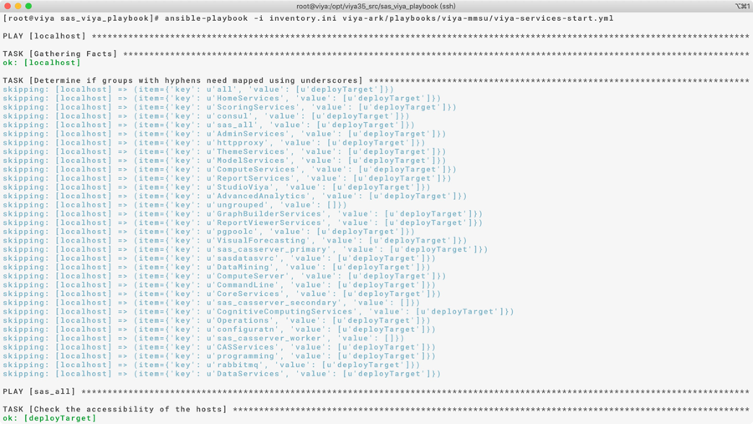

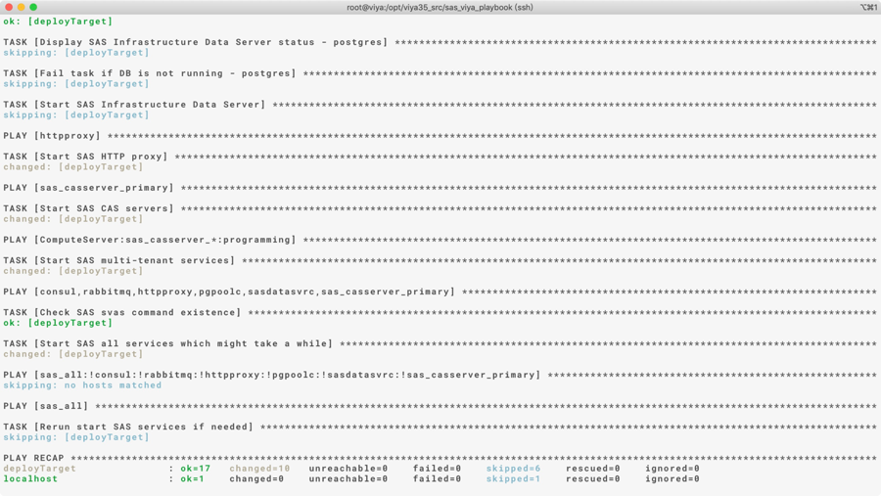

## 重啟Viya所有服務

|  |
| --- |
| [root@control01 sas_viya_playbook]# ansible-playbook -i inventory.ini viya-ark/playbooks/viya-mmsu/viya-services-restart.yml |

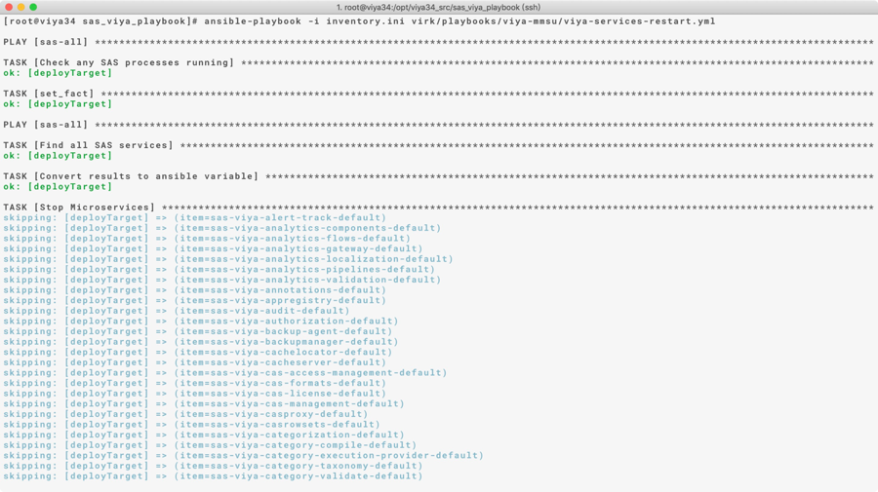

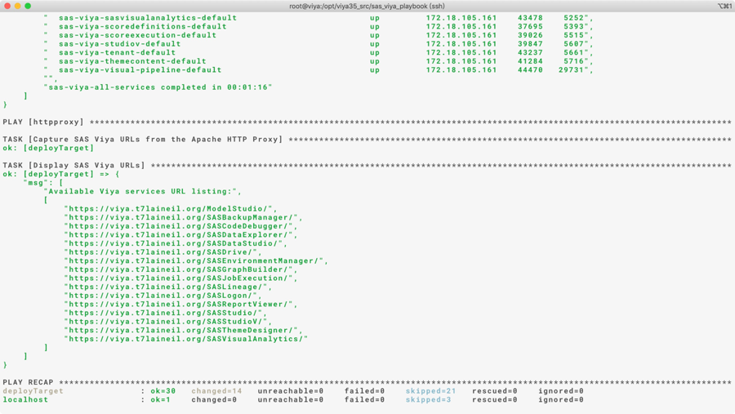

# **解除安裝**

至control01停止服務並跑deploy-cleanup.yml移除整座Viya

|  |
| --- |
| [root@control01 ]# cd /CREPOS/viya_35c/sas_viya_playbook  [root@control01 ]# ansible-playbook -I inventory.ini viya-ark/playbooks/viya-mmsu/viya-services-stop.yml  [root@control01 ]# ansible-playbook -i inventory.ini deploy-cleanup.yml |

檢查每台server上的viya rpm已被清除

|  |
| --- |
| [root@control01 ]# ansible cluster -m shell -a ‘sudo rpm -qg SAS’ |

Note: 如果未順利被清除，可至未清除乾淨的server上運行**sudo rpm -e $(rpm -qg SAS) –nopreun**

檢查每台server上的/opt/sas下面的viya和spre folder已被清除或rename

|  |
| --- |
| [root@control01 ]# cd ~  [root@control01 ]# ansible cluster -m shell -a ‘ls -lr /opt/sas’ |

檢查每台server上的sas和cas process均已停止

|  |
| --- |
| [root@control01 ]# cd ~  [root@control01 ]# ansible cluster -m shell -a ‘ps -ef | grep sas’  [root@control01 ]# ansible cluster -m shell -a ‘ps -ef | grep cas’ |

Note: 如果process未順利停止，可至未清除乾淨的server上手動kill process

# **重新安裝步驟**

此處步驟僅限於重新安裝於同一座cluster (hostname 不變)

1. 執行default and binary備份
2. 參照7執行解除安裝
3. 參照[1.12](#_配置inventory.ini(control01)_1)檢查inventory.ini設定正確
4. 參照 [1.13](#_配置vars.yml(control01))檢查vars.yml設定正確(e.g. license 和 repository_warehouse)
5. 參照 [1.14](#_配置sitedefault.yml(control01))檢查sitedefault.yml設定正確
6. 參照 [1.15](#_配置Auto_deployment所需的檔案(control01))檢查auto deployment所需檔案
7. 參照 [1.16](#_配置pre-install_playbook(control01))檢查pre install playbook設定正確
8. 參照 [1.17](#_系統檢查(control01))系統檢查
9. 參照[2.3](#_執行自動化安裝(control01)_1)執行自動化安裝
10. 參照 [3.3](#_執行自動化安裝後驗證_(control01)) 執行自動安裝後設定
11. 參照 4 執行手動安裝後設定
12. 參照6.2關閉Viya服務
13. 參照6.3開啟Viya服務
14. 參照6.1查看viya服務狀態